Updated November 2016

Long term care preparedness

Base Plan with Appendixes and Annexes

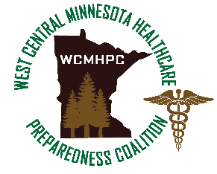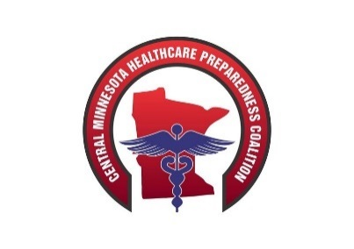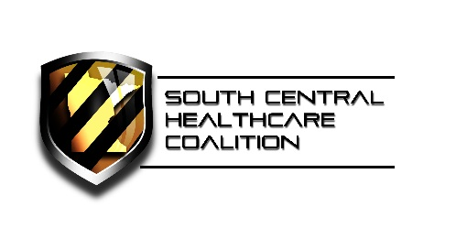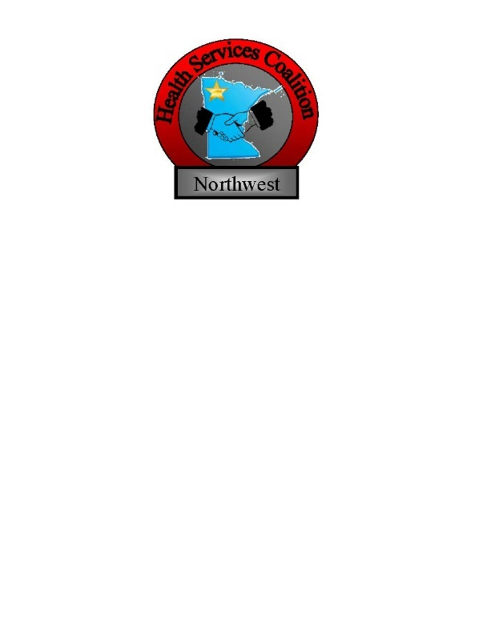

Table of Contents

2 Introduction 4

3 Overview of All Hazards Approach to Planning 4

3.1 All Hazards 4

3.2 Probability 5

3.3 Risk 6

3.4 Preparedness 7

4 Plain language 7

5 Hazard Vulnerability Analysis Tool 9

5.1 Hazard Vulnerability Analysis 10

5.2 Sample HVA tool 11

6 Emergency Operations Plan Tool 12

6.1 Incident Command System 12

6.2 Benefits of utilizing Incident Command in health care 12

6.3 Basic ICS Job Action Overview 14

7 Organization Information / Contact Information 16

8 Facility- Specific Information 17

9 Decision making 17

9.1 Sample decision making tree 17

10 HIPAA in emergent situations 18

11 Ethical guidelines 18

12 Evacuation plan 19

12.1 Transportation plan 20

12.2 Evacuation Destination Information 20

12.3 Staffing Plan 21

12.4 Attachments and Documents 21

13 Sheltering in place 21

14 Memorandums of understanding 22

15 Recovery plan 23

16 Staff care plan 23

17 Exercise, evaluation and improvement planning 23

18 Regional resources and support agencies 24

19 List of Appendixes 25

19.1.1 Appendix A – CMS Emergency Preparedness Checklist for Effective Healthcare Facility Planning 25

19.1.2 Appendix B – Facility Hazard Vulnerability Analysis 25

19.1.3 Appendix C- Organization chart/Job Action Sheets/ICS Quick start guide 25

19.1.4 Appendix D - Facility Contact Lists 25

19.1.5 Appendix E - Facility Specific Information 25

19.1.6 Appendix F– HIPAA Waiver Toolkit 25

19.1.7 Appendix G - Evacuation Plan and Checklists, and Transportation agreements 25

19.1.8 Appendix H - Facility Shelter in Place plan, Supply and Equipment lists, and checklists 25

19.1.9 Appendix I – MOU templates 25

19.1.10 Appendix J– Recovery checklists 25

19.1.11 Appendix K – Staff Care Plan documentation 25

19.1.12 Appendix L – Exercise, Evaluation, and Improvement planning checklist and AAR/IP 25

19.1.13 Appendix M – Regional Contacts and Important Resources 25

19.1.14 Annexes – Additional templates 25

19.1.14.1 Apartment Evacuation policy 25

19.1.14.2 Behavioral health – Psychological First Aid 25

19.1.14.3 Bioterrorism threats 25

19.1.14.4 Bomb Threat policy 25

19.1.14.5 Chemical Spills 25

19.1.14.6 Communications 25

19.1.14.7 Electrical power outage policy 25

19.1.14.8 Elevator policy 25

19.1.14.9 Emergency notification of Administrator 25

19.1.14.10 Fire policy 25

19.1.14.11 Heat & Humidity policy 25

19.1.14.12 Loss of telephone service policy 26

19.1.14.13 Missing person policy 26

19.1.14.14 Severe weather policy 26

19.1.14.15 Water shortage policy 26

19.1.14.16 Winter storm safety policy 26

19.1.14.17 Workplace Violence/Hostile event 26

20 Acronyms 27

# Introduction

The Minnesota Long Term Care (LTC) Preparedness Toolkit was developed to assist with emergency preparedness planning for this specialized health care population. LTC facilities, as they are referred to in the toolkit, include nursing homes, skilled nursing facilities, and assisted living facilities.

Members of the Minnesota Department of Health, Care Providers of Minnesota, Aging Services of Minnesota, and regional representation from the Health Care Preparedness Program developed this tool to assist LTC facilities in emergency preparedness. Latest revisions to this toolkit took place in the fall of 2016 with additional input from individuals representing LTC facilities. The primary focus of the revision is the updated CMS emergency preparedness requirements which were released September 2016 with the implementation beginning in November 2017.

**See Appendix A for CMS Emergency Preparedness Checklist for Effective Healthcare Facility Planning**

This toolkit can be used by LTC facility owners, administrators, and staff. Information includes: sample templates, forms, and suggested resources to develop and/or enhance facility emergency preparedness plans within LTC throughout the state of Minnesota. It should not be viewed as a static document but one that provides a foundation for an All Hazards approach to preparedness, planning, and response activities.

It is recommended that not one person at any facility be charged in preparing this plan. Rather, it is suggested that an internal committee be formed from various disciplines within the facility to work on this plan. This toolkit serves as a base template that can be customized to the needs of each facility. The tools in this document are important items you will need to address prior to an event occurring.

# Overview of All Hazards Approach to Planning

Recent events such as Hurricane Sandy, the Red River floods of 2009 and other events have stressed all types of health care facilities and shown that better planning is needed. Because different types of events present different challenges to health care entities, an all hazards approach to planning is proven to be most efficient and most beneficial. An all hazards response plan must be based on the hazards that are most likely to affect a facility and it is important in directing how a response may unfold and what the correct response actions would be. In order to identify the most likely hazards, a hazard vulnerability analysis should be completed (see section 3 for more information on the Hazard Vulnerability Analysis info).

## All Hazards

Hazards may be thought of as extreme events. Hazard vulnerability analysis is often based on an “all hazards approach.” This means that one begins with a list of all possible disasters, regard­less of their likelihood, geographic impact, or potential outcome. The list may be the result of a committee brainstorming session, research, or other methodology, and should be as comprehen­sive as possible.

It may be helpful to divide the potential hazards into categories to focus the thought process. Typical categories may include natural hazards, technological hazards, and human events. These are certainly not requirements, and should not be considered to be constraining. There is overlap between the categories as well. For example, a transportation accident may be considered to be a technological hazard rather than a human event.

Once the complete hazards listing is developed, look at it critically for items that might be appropri­ately grouped together as one hazard category. Organize the list into categories.

Finally, a prioritization process should be under­taken to determine the course of emergency planning. The realistic factors of time and money play a role in decisions of preparedness, and facilities must choose to apply their limited resources where they will have the most impact. To work toward this end, each identified hazard will be evaluated for its probability of occurrence, risk to the organization, and the organization‘s current level of preparedness.

## Probability

Disasters, by nature, are not predictable. Still, familiarity with the geographic area and research will identify those for which the facility must be most prepared. It is important to consider both expected occurrences as well as unlikely scenarios.

Regularly occurring natural disasters are typically well known within a community. The community will often be able to provide data that include hundred-year flood plains, weather information for the locale, etc. The weather bureau may also be able to provide input. In addition, community emergency planning agencies may have already done a community-based hazard vulnerability analysis. This may not provide a complete solution, but it will provide a start.

Nursing homes and long term care facilities have become increasingly dependent on technology to provide their normal services. As a result, a failure of a given technological system can put a facility into an internal state of disaster. Beyond the walls of a facility itself, technology in the community can fail or lead to an incident creating victims in need of medical care or otherwise affecting the health care facility. Exter­nal transportation failures can lead to unavailability of supplies, which can also be disastrous. In order to determine the probability of these events, examine the internal technology in the facility and the availability of backup sys­tems to compensate for failure. Service records and system failure reports can be used to evaluate the likelihood that these incidents may occur. Types of industry in the community should also be considered in this assessment for a technological disaster with broad community impact.

Establishing the probability of occurrence of these events is only part objective and statisti­cal—the remainder can best be considered intuitive or highly subjective. Each hazard should be evaluated in terms that will reflect its likelihood. The tool presented in this document, for example, uses the qualitative terms of *high, medium, low,* or *no probability of occurrence*. A factor may be used, but is not required, to quantitatively assess the probability.

## Risk

Risk is the potential impact that any given hazard may have on the organization. Risk must be analyzed to include a variety of factors, which may include, but are not limited to the following:

* Threat to human life
* Threat to health and safety
* Property damage
* Systems failure
* Economic loss
* Loss of community trust/goodwill
* Legal ramifications

The threat to human life and the lesser threat to health and safety are considered to be so signifi­cant that they are given separate consideration on the hazard vulnerability analysis document. Consider each possible disaster scenario to determine if either of these human impact threats is a factor.

The remaining three categories on the analysis tool classify risk factors as to their disruption to the organization in high, moderate, or low classifica­tion. From the bulleted list above, property damage, systems failure, economic loss, loss of community trust, and legal ramifications are all considered together to determine the level of risk.

Property damage in a disaster situation may be a factor more often than not, although the degree of damage may vary. Seismic activity may virtually destroy a building, or render it uninhabitable. In the most severe scenario of this type, the property damage will also include equipment and supplies within the facility. Other hazards may impact only a portion of the building, for example, flooding only in the basement. Perhaps severe weather resulted only in a few broken windows.

Systems failure may have been the cause of the emergency in the first place. A major utility failure may require backup equipment or service that is significantly less convenient, or may not be sustainable for a lengthy time. Even though an alternate system is available, the failure will typically cause a facility to implement emergency plans. Systems failure, however, is not necessarily an isolated occurrence. It can be the result of another hazard, such as flooding damage to an emergency generator.

In any disaster, economic loss is a possibility that deserves consideration. If a facility cannot provide services because of disaster, revenue will be affected. It may result from damage to the physical plant or equipment, inability to access the facility due to transportation or crowd control issues, or a negative public relations impact. Long term care entities are businesses like any other, and economic disruptions can be managed for only a limited time. Each hazard must be analyzed for its adverse financial impact.

An issue of loss of goodwill has the potential for legal ramifications in the aftermath of a disaster. If errors were made in the management of the emergency, if lives were lost or injuries occurred, the facility could face legal action. It is advisable to consult risk management and/or the facilities legal counsel if questions exist in this area.

## Preparedness

Finally, an evaluation of the organization’s current level of preparedness to manage any given disaster should be undertaken. This process should involve the input of community agencies. The health care facility will not be responding to an emergency in a vacuum, and there may be com­munity resources to support the facility.

Long term care facilities have done disaster planning for many years and are well prepared to manage many types of emergencies. However, the scope of current emergency planning has expanded and the typical organization will find at least some hazards from the all-hazards list for which improvements are needed. The current status of emergency plans and the training status of staff members to respond to any given hazard is a factor to consider in evaluating preparedness.

The health care organization may carry insurance to compensate for losses suffered because of some emergencies. Backup systems may also be thought of as insurance protecting against certain occurrences. The availability of insurance cover­age or backup systems should be factored into the determination of the current preparedness status.

The hazard vulnerability analysis tool in this document evaluates the organization’s prepared­ness level as good, fair, or poor. An alternative way of approaching this issue is to evaluate each hazard based on the amount of improvement needed, for example, slight, moderate, or major. Both systems will yield similar results.

Planners within the organization should evaluate this section critically and realistically. Failure to do so may result in a false sense of security, which may result in an increased impact on some of the risk factors discussed above. Appropriate evalua­tion of preparedness will direct the organization’s effort and resources earmarked for emergency management.

# Plain language

Utilization of plain language decreases staff confusion and ensures transparency for residents and visitors. The linked toolkit offers suggestions for how to utilize plain language in emergency overhead paging.

Minnesota Hospital Association. (2011). *Plan Language Emergency Overhead Paging.* St. Paul, MN. <https://www.mnhospitals.org/Portals/0/Documents/ptsafety/overhead-paging-toolkit-2011.pdf>

|  |  |
| --- | --- |
| **Emergency Situation** | **Emergency Code** |
| **Severe Weather** | **Weather Alert + Descriptor** |
| * **Thunderstorm Watch** | Weather Alert + Thunderstorm Watch |
| * **Thunderstorm Warning** | Weather Alert + Thunderstorm Warning  (+ Lockdown/Shelter-in-Place/Evacuate) |
| * **Tornado Watch** | Weather Alert + Tornado Watch |
| * **Tornado Warning** | Weather Alert + Tornado Warning  (+ Lockdown/Shelter-in-Place/Evacuate) |
| **Security Alert** | **Security Alert + Descriptor + Location** |
| * **Active Shooter** | Security Alert + Active Shooter + Location  (+ Lockdown/Shelter-in-Place/Evacuate) |
| * **Bomb Threat** | Security Alert + Suspicious Device/Bomb Threat  (+ Lockdown/Shelter-in-Place/Evacuate) |
| * **Civil Disturbance** | Security Alert + Civil Disturbance + Location  (+ Lockdown/Shelter-in-Place/Evacuate) |
| * **Missing Person/ Elopement** | Missing Person + Descriptor + Location (+ Lockdown, as applicable) |
| * **Threat of Violence** | Security Alert + Threat of Violence + Location  (+ Lockdown/Shelter-in-Place/Evacuate) |
| **Emergency Alert** | **Emergency Alert + Descriptor + Location** |
| * **Electric Power Outage** | Emergency Alert + Electric Power Outage + Location  (+ Lockdown/Shelter-in-Place/Evacuate) |
| * **Fire** | Emergency Alert + Fire Alarm + Location  (+ Lockdown/Shelter-in-Place/Evacuate) |
| * **Flood** | Emergency Alert + Flood + Location  (+ Lockdown/Shelter-in-Place/Evacuate) |
| * **Hazardous Material** | Emergency Alert + Hazardous Material + Location  (+ Lockdown/Shelter-in-Place/Evacuate) |
| * **Natural Gas Leak** | Emergency Alert + Natural Gas Leak + Location  (+ Lockdown/Shelter-in-Place/Evacuate) |
| * **Evacuation** | Emergency Alert + Mandatory Evacuation + Descriptor + Location  (+ Lockdown/ Move to Staging/Assembly Areas) |
| * **Medical Emergency** | Emergency Alert + Nurse Stat + Location |
| * **Shelter in Place** | Emergency Alert + Shelter in Place + Descriptor + Location  (+ Lockdown/ Move to Staging/Assembly Areas) |
| (https://www.mnhospitals.org/Portals/0/Documents/ptsafety/overhead-paging-toolkit-2011.pdf) | |

# Hazard Vulnerability Analysis Tool

The *hazard vulnerability analysis tool* is simply that -- a tool. It is provided as a resource and a starting point for organizations to evaluate their vulnerability to hazards. It may be modified or changed in any way that is appropriate for individual facility use.

This document uses a quantitative method to evaluate vulnerability, which is also not required. The facility may find a qualitative method equally as effective.

Using this tool, each potential hazard is evaluated as described above and scored as appropriate in the areas of probability, risk, and preparedness. The factors are then multiplied to give an overall total score for each hazard. Note that a hazard with no probability of occurrence for a given organization is scored as zero and will automatically result in a zero for the total score.

Listing the hazards in descending order of the total scores will prioritize the hazards in need of the facility’s attention and resources for emergency planning. It is recommended that each organiza­tion evaluate this final prioritization and determine a score below which no action is necessary. The focus will then be on the hazards of higher priority. Establishing a cutoff value, however, does intro­duce risk to the organization for those hazards falling below. The facility has determined that there is some probability and risk of the event occurring, and has chosen to exclude it from the planning process. It must be noted that the acceptance of all risk is at the discretion of the organization.

## Hazard Vulnerability Analysis

**INSTRUCTIONS:**

Evaluate every potential event in each of the three categories of probability, risk, and preparedness. Add additional events as necessary.

Issues to consider for probability include, but are not limited to:

1. Known risk

2. Historical data

3. Manufacturer/vendor statistics

Issues to consider for risk include, but are not limited to:

1. Threat to life and/or health

2. Disruption of services

3. Damage/failure possibilities

4. Loss of community trust

5. Financial impact

6. Legal issues

Issues to consider for preparedness include, but are not limited to:

1. Status of current plans

2. Training status

3. Insurance

4. Availability of back-up systems

5. Community resources

Multiply the ratings for each event in the area of probability, risk and preparedness. The total values, in descending order, will represent the events most in need of organization focus and resources for emergency planning. Determine a value below which no action is necessary. Acceptance of risk is at the discretion of the organization.

Facilities are to review and update their HVA annually.

## Sample HVA tool

***Note: an electronic HVA can also be accessed through your regional health care coalition. The electronic version looks like***



**See Appendix B for HVA.**

# Emergency Operations Plan Tool

The following tools serve as specific components that will allow your organization to plan and prepare to meet the needs of both your residents and staff in the event of an incident. Each tool will be preceded by a descriptor of the tool and instructions where necessary. These tools when taken as a whole are the basis of an Emergency Operations Plan (EOP).

Once the EOP has been developed, it is also the role of the team to be sure that this plan is shared with appropriate staff and that internal training is conducted. This training should be incorporated into regularly scheduled trainings as staff changes do occur and keeping current on any material requires periodic review.

For an EOP to maintain viability and usefulness, it needs to be updated on a scheduled basis. As each facility grows and changes, the EOP also needs to be modified to reflect those changes. Once these tools are completed, your EOP will be well on the way to serving each facility’s need to care for staff and residents.

## Incident Command System

In any emergency response, it is critical that clear lines of authority (chain of command) exist within the facility. This ensures that there is timely and efficient decision-making and communication. It is important to define a chain of command, designate a facility incident commander, and clarify their authority and decision-making ability. This is an important aspect of the disaster plan.

Disaster planning needs to start at the top of the organization. Bring the leaders of the organization into the planning process from the very beginning to identify and agree upon the best course of action for the health care facility, its residents and staff. Organization leaders should discuss the financial and clinical implications of the various proposed response strategies. This may include items such as closing to new admissions or agreeing to be a “surge” or overflow setting for the local hospital. Medical and administrative priorities need to match, and your facility’s leadership team needs to be clear about its role and authority.

Incident Command Systems (ICS) can be used at organizations both large and small — it can even be used by just one person. If you have a small organization, the same person may fill multiple spots on the ICS organizational chart. Assure through practice and exercise that one designated person is not disproportionately overburdened with her or his roles in an emergency. It is recommended that, at a minimum, frontline staff obtain the basics of ICS by taking ICS 100, ICS 200, and ICS 700. These courses and more can be found at: <https://www.fema.gov/training-0>

## Benefits of utilizing Incident Command in health care

**Common terminology/clear text**

The use of common terminology provides for a clear message and sharing of information. It avoids the use of codes, slang, or discipline specific verbiage that may not be clearly understood by all planning and response partners. Common terminology helps to define the organizational structure: as an example, the identification of sections, section chiefs, and branch directors. Another key benefit of common terminology is the ability to share resources in the response, such as personnel to oversee incident management or operations. By using consistent terminology, the opportunity to develop memorandums or agreements to share personnel is enhanced.

**Modular organization**

The ICS structure begins from the top and expands as needed by the event. Positions within the structure are activated as dictated by the incident size or complexity. As complexity increases, the ICS organization expands. Only those functions or positions necessary for an incident are activated. This will be clearly demonstrated in subsequent sections that detail the incident management team along with their roles and responsibilities.

**Management by objectives**

The Incident Commander initiates the response and sets the overall command and control objectives. The mission of the response is defined for all members of the response team through a clear understanding of the organization’s policy and direction. This includes an assessment of the incident from the current situation to projected impacts. To meet the overall mission, or command objectives, individual sections will establish incident objectives as well as the strategies to achieve these objectives through clear tactics. Because emergency response is not “business as usual,” clearly defined objectives will allow staff to focus on the roles in the response, avoiding duplication of efforts or omission of critical actions.

**Incident Action Planning**

The development of objectives is documented in the Incident Action Plan (IAP). A written plan provides personnel with direction for taking actions based on the objectives identified in the IAP and reflects the overall strategy for incident management while providing measurable strategic operations for the operational period. To ease this process, ICS forms are designed and developed for nursing homes and are contained within the California Nursing Home ICS guidebook (<http://cahfdisasterprep.com/NHICS/GuidebookTools.aspx>).

**Manageable span of control**

A key concept in ICS is maintaining a span of control that is both effective and manageable. Because emergency events are not business as usual situations, the span of control for operations that are not routine should be kept at an effective number. Within ICS, the optimum span of control is one supervisor to five reporting personnel. If the number falls outside these ratios, the incident management team should be expanded or consolidated.

**Pre‐designated incident locations/facilities**

In the planning stages, planners should determine the location of their response and coordination sites, including the coordination and command sites. Within ICS, sites are identified for both scene and regional coordination, such as helicopter landing zones, staging areas, command posts, and emergency operations centers. Planners within the nursing home or long‐term care facility should identify sites for ICS management, staging areas for receipt of supplies and equipment, evacuation sites if the infrastructure is unsafe, and so on.

**Resource management**

Resources are assets that are used in the response. Examples include personnel, equipment, food, communications, supplies, vehicles, etc. When making requests for assistance from other health care facilities, local emergency management, regional health care coalitions and other state partners have a clear picture of current and needed resources. This level of awareness allows those providing the support to provide the necessary assets through a clear understanding of current capability.

**Integrated communications**

There are three elements within integrated communications: modes, plans and networks. The modes include the hardware systems that transfer information, such as radios, cell phones, and pagers. Plans are developed in advance and outline how to best use the available modes through a clear and concise communication policy and procedure (for example, determining who can use radios and what information should be communicated). Networks are identified within the jurisdiction and will determine the procedures and processes for transferring information internally and externally.

**Common command structure**

The ICS provides for a common command structure that identifies core principles for an efficient chain of command. *Unity of Command* dictates that each person within the response structure reports to only one supervisor. A *single command* exists when a single agency or discipline responds to an event; for example, the fire service at a warehouse fire is commanded by a fire captain or chief. When multiple agencies or disciplines are working together at a scene, there is a *unified command* structure that allows for coordination in response actions. For nursing homes, this may occur when the facility is the scene of the incident, such as a fire. The nursing home administration and the fire command work together in a unified command structure.

## Basic ICS Job Action Overview

The organization chart is the base to ICS and is utilized when a response to any incident is necessary. Specific personnel placed in the various roles are determinant on the skills and position with the organization.

* **Incident Commander**: Leads the response, appoints section leaders, approves plans and key actions (CEO, administrator, Director of Nursing (DON), nursing supervisor.)
* **Operations Section**: Handles key actions including first aid, search and rescue, fire suppression, securing the site (DON, Department supervisors, nursing supervisor, direct care staff.)
* **Planning Section**: Gathers information, thinks ahead, makes and revises action plans and keeps all team members informed and communicating. (Safety committee, Continuity of operations planning team, etc.)
* **Logistics Section**: Finds, distributes, and stores all necessary resources (maintenance supervisor, purchasing, human resources director)
* **Finance Section:** Tracks all expenses, claims, activities, and personnel time and is the record keeper for the incident (controller, accounts department, payroll.)
* **Public Information Officer**: Provides reliable information to staff, visitors and families, the news media and concerned others as approved by the Incident Commander. (Social Worker, Administration Personnel)
* **Safety Officer**: Ensures safety of staff, residents, and visitors; monitors and corrects hazardous conditions. Has authority to halt any operation that poses immediate threat to life and health.
* **Liaison Officer**: Serves as the primary point of contact for supporting agencies assisting the facility. (Social Worker, Administration Personnel)

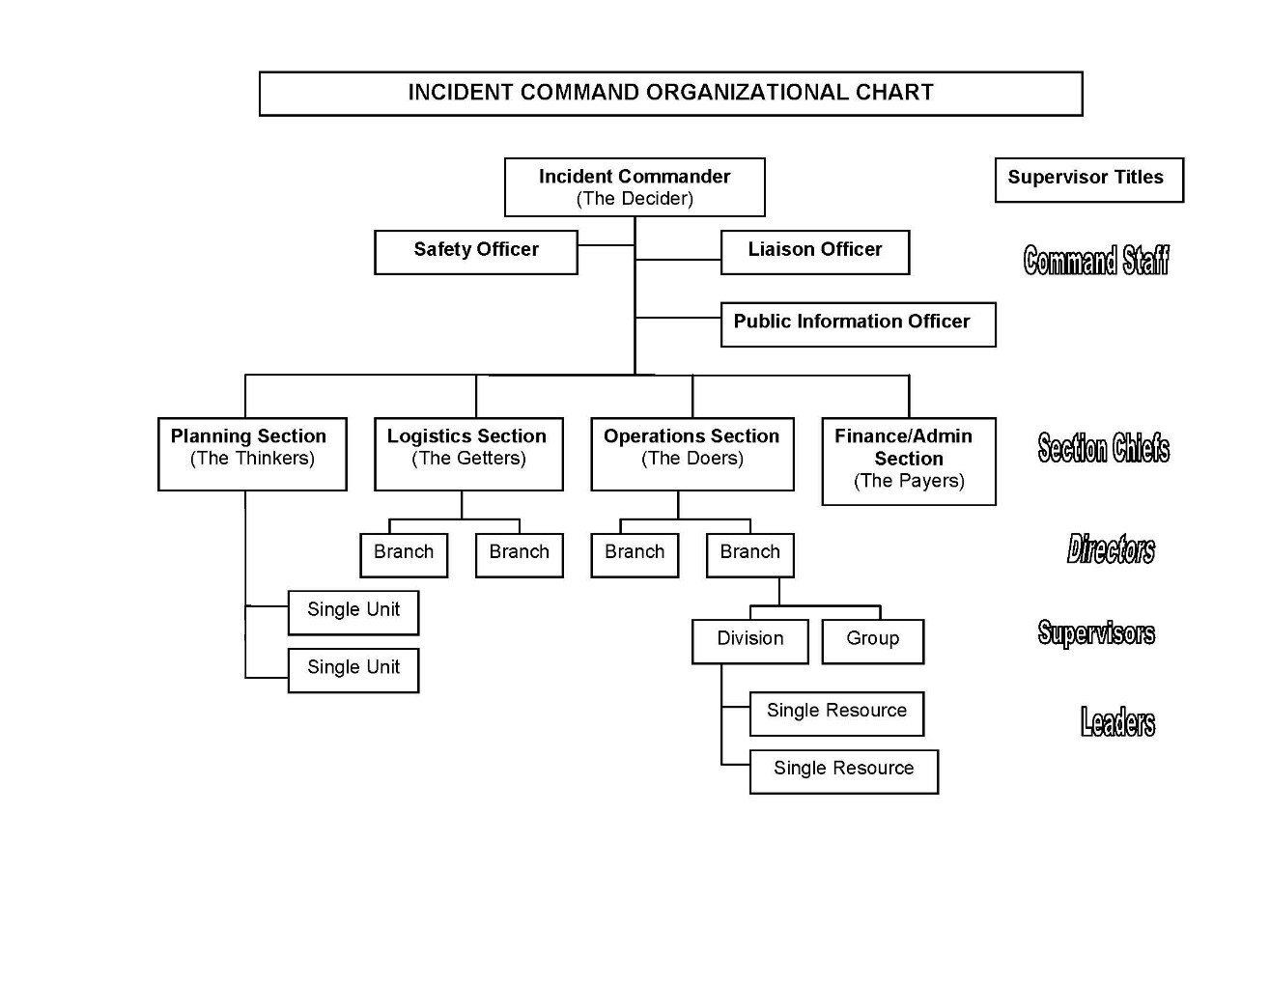Example Organization chart:

Depending on the size of the facility, one person may occupy multiple positions **within the section.** You do not need to activate all positions – only activate what you need for the incident. This is your basic Incident Command. If part of a larger system i.e.: health organization, you will need to know where your ICS fits within that organization’s structure.

**See Appendix C for Organization Chart/Job Action Sheets**

An online version of the Heath Care Incident Command system (HICS) specifically designed with the Long Term Care facility in mind is located at <http://www.smrrc.org/hics.htm>.

The following chart is a list of persons that can be used to fill a role in the Organization Chart:

|  |  |
| --- | --- |
| Incident Command Position | Facility role |
| Incident Commander | Administrator/CEO |
| Medical Director/Specialist | Medical Director/Nurse Consultant |
| Public Information Officer | Administrator/Media Relations |
| Liaison Officer | Community specialist/assistant administrator |
| Safety Officer | Maintenance |
| Operations Section Chief | Director of Nursing/Nursing Supervisor |
| Resident Services Branch Director | Director of Staff Development |
| Nursing Unit Leader | Nursing supervisor/Charge Nurse |
| Admit/Transfer & Discharge Unit Leader | Nursing supervisor/Charge Nurse/Admissions |
| Infrastructure Branch Director | Housekeeping supervisor |
| Dietary Unit Leader | Dietary supervisor |
| Environmental Unit Leader | Housekeeping |
| Physical Plant/Security leader | Maintenance |
| Planning Section Chief | Assistant administrator |
| Situation Unit Leader | Admissions |
| Documentation Unit leader | Medical Records |
| Logistics Section Chief | Chief Finance Officer/Assistant Administrator |
| Services Branch Director | Accounts manager |
| Communications Unit Leader | Maintenance |
| IT/IS Unit Leader | IT/IS staff |
| Supply Unit Leader | Purchasing |
| Staffing/Scheduling Unit Leader | Human Resources/Staffing |
| Transportation Unit Leader | Maintenance/Activity staff/Rehab |
| Finance/Admin Section Chief | Chief Finance Officer/Accounting |
| Time Unit Leader | Payroll/billing |
| Claims Unit Leader | Risk Manager/Quality manager |
|  |  |

# Organization Information / Contact Information

For an EOP to be functional, it is dependent on current and accurate information. Key to any response is the ability to know who to notify and how to get in touch with these personnel. For this reason, having current and accurate organizational information along with current information regarding key staff is essential. An effective response cannot occur without personnel. The following information needs to be maintained and updated periodically so timely communications and response can occur. The following information is broken out into three separate areas:

1. **Organizational Information:** contains the contact information for facility ownership and leadership.
2. **Emergency Contact Roster-Internal:** contains the contact information for supervisors/leaders within the organization.
3. **External Contact Information-External:** contains emergency contacts, contractors, and outside support services

**See Appendix D for Contact lists**

# Facility- Specific Information

This information is made up of the location and characteristics of the facility and the people associated with it. As with any response, it is important to understand the physical features of a facility in order to maintain safety and efficiency. It is also important to understand the occupancy and certain specific information regarding the occupants. The facility-specific information provides descriptions of the facility and some baseline information regarding staff and residents. The information contained should be reviewed and updated annually.

**See Appendix E for Facility Specific Information**

# Decision making

During an unplanned event knowing what needs to be done to ensure the safety of the residents as well as the staff can be extremely stressful. The facility should have a clearly delineated decision making tree.

## Sample decision making tree

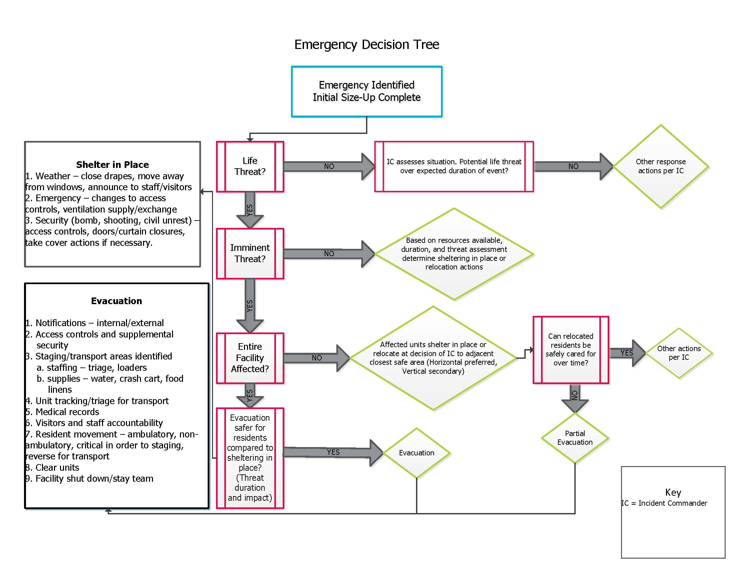

# HIPAA in emergent situations

During emergent situations, the decision to share private patient/resident health care information is difficult. To ensure that there is continuity of care there may be situations where it is necessary to waive HIPAA.

**See Appendix F for HIPAA Waiver toolkit.**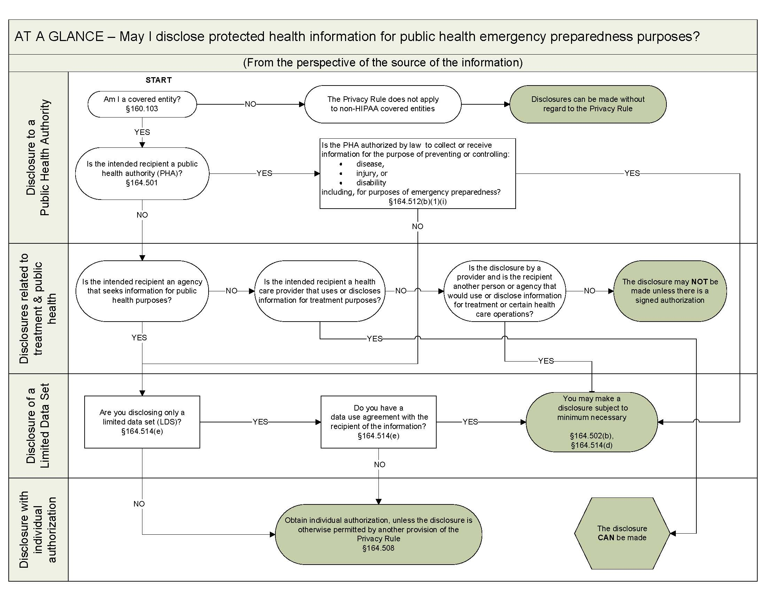

# Ethical guidelines

The Institute of Medicine’s *Guidance for Establishing Crisis Standards of Care for Use in Disaster Situations* offers a useful framework which fundamentally relies on the principle of justice.

Ethical Values:

* Fairness – who receives what and at what point
* Professional Duty – do no harm, do not abandon
* Stewardship – allocating scarce resources; utilitarianism

Ethical Process Elements:

* Transparency – communication to stakeholders
* Consistency – nondiscrimination
* Proportionality – elevating response during emergency
* Accountability – acting upon duty to respond

During an emergency, the following events require incorporation of sound ethical considerations:

1. Triaging – There are two phases of triage: reactive and proactive. Reactive triaging occurs when there is no notice of a disaster such as an explosion or tornado. Triaging must occur “in the moment.” Proactive triage would be the prioritization of which resident to evacuate first prior to an impending crisis.
2. Allocation of Resources - Workforce members should know what resources are available during a crisis, where supplies are stored, and have the tools needed to determine how scarce resources will be issued.
3. Workforce members should be prepared to adjust their standards of care during an emergency. Considerations include ensuring individuals are trained to provide care normally outside of their professional practice.

# Evacuation plan

While evacuation is typically not preferred, there may be times when this option is safest for the residents and staff. Due to the varied abilities of nursing home residents, evacuation can be a daunting task without appropriate consideration and planning ahead of time. Prior planning regarding how residents will be transported, who will provide the transportation, what specialty types of vehicles will be needed and where they will come from all need to be prearranged in order to maximize the safety of residents and staff. Evacuation planning also includes determining what supplies, food, water, medications, and other physical items will be needed in order to maintain safety. Pre-determined locations should be identified where residents can be taken that will adequately meet their needs. Identifying pre-determined locations and having discussions ahead of time will ensure a smooth transition. Two sample memoranda are provided to serve as templates (See Appendix I). Additionally, it should be noted that having an evacuation agreement with more than one facility would be appropriate. Traditionally, facilities often choose the closest like facility with which to partner. However, a second facility some distance away may be prudent in the event that the closest facility may be similarly affected and unable to handle the transfer request.

The following pages are specifically dedicated to looking at evacuation needs. If additional evacuation and shelter-in-place planning resources are desired, please refer to the Minnesota Department of Health website.

## Transportation plan

The transportation plan should describe how the residents will be transported to the sheltering facilities. It should include as an attachment any contracts or Memorandums of Agreement with transportation companies, churches or ambulance services, or other transportation modality. The transportation plan should include:

a. The number and types of vehicles required.

b. How the vehicles will be obtained.

c. Who will provide the drivers.

d. Medical support to be provided for the patient or resident during transportation. The following support needs should be considered:

1. Residents who are independent in ambulation.
2. Residents who require assistance with ambulation.
3. Residents who are non-ambulatory.
4. Residents with cognitive impairments.
5. Residents with equipment/prosthetics (equipment/prosthetics should accompany residents and should be securely stored in the designated mode of transportation).

e. Estimation of the time to prepare residents for transportation.

f. Estimation of the time for the facility to prepare for evacuation.

g. Estimation of time for the patient or resident to reach the sheltering facility.

h. Detailed route to be taken to each sheltering facility if possible.

i. Description of what items must be sent with the patient or resident such as:

1. The patient’s medical record, which contains medications the patient is taking, dosage, frequency of medication administration, special diets, special care, etc.

2. A three-day supply of medications (if possible).

3. Special medical supplies the patient may need.

4. Other items such as clothing, incontinence diapers, etc.

j. The medical records should be provided to the receiving facility and remain with the receiving facility until the patient or resident is transferred back to the sending facility or to another facility.

k. Records should be maintained of which residents are transported to which facilities.

## Evacuation Destination Information

The Sheltering Plan should describe where the residents will be transported. The receiving facility should be appropriate for the level of care required for the residents being evacuated. The plan should include as an attachment any contract, memorandum of agreement, or transfer agreement the facility has with a receiving facility. The following should also be included in the plan:

a. Sleeping plan

b. Feeding plan

c. Medication plan

d. Accommodations for relocated staff

e. Number of relocated residents that can be accommodated at each receiving facility

## **Staffing Plan**

The Staffing Plan should include how the relocated residents will be cared for at the sheltering facility as well as the number and type of staff that is needed at the evacuating facility to help evacuate the residents. The Staffing Plan should include:

a. Description of how care will be provided to relocated residents

b. Identification of number and type of staff needed to evacuate the facility and to

accompany residents to the sheltering facility

c. Plan for relocating facility staff

d. A contingency plan if facility staff cannot make it into the shelter due to their own family’s needs.

## Attachments and Documents

The following documents should be included as attachments to the Evacuation Plan:

a. Sheltering agreements between the facility and the receiving facility (must be update annually)

b. Transportation agreements between the facility and ambulance companies, bus services, churches, etc. (must be updated annually)

c. Documentation of any coordination between law enforcement, fire departments, etc.

**See Appendix G for Evacuation plans, checklists and transportation agreements.**

# Sheltering in place

In certain situations, such as a tornado or chemical incident, your facility may be better off to stay and shelter in place. The facility needs to plan for sheltering in place. In an emergency, your facility may be without telephone or other communications, electric power, or water and sewer service for several days. The facility must be able to exist on its own for at least 72 hours without outside assistance. Your plan should include provisions for resident care (monitoring of medical conditions), facility safety and security, food, water, medications, contact with first responders (fire, police, EMS, etc.), public health, transportation, staff, lighting, temperature control, waste disposal, and medical supplies.

The sheltering in place plan is not to be specific to the event requiring sheltering, instead, the plan should contain the following:

* Plan in place describing how three days of non-perishable meals are kept on hand for residents and staff. The Plan should include special dietary requirements.
* Plan in place describing how 72 hours of potable water is stored and available to residents and staff.
* Plan in place identifying 72 hours of necessary medications that are stored at the facility and how necessary temperature control and security requirements will be met.
* Plan in place to identify staff that will care for the residents during the event including any transportation needs that the staff might have and how the facility will meet those needs.
* Plan in place for an alternative power source, such as an onsite generator, and describe how 72 hours of fuel will be maintained and stored. Alternate power source plan provides for necessary testing of the generator.
* Plan in place describing how the facility will dispose of or store waste and biological waste until normal waste removal is restored.
* Emergency Communications Plan in place, such as for cell phones, hand held radios, pager, satellite phone, laptop computer for instant messaging, HAM radio, etc.
* Adequate planning considerations given to the needs of residents, such as dialysis patients.
* Adequate planning considerations given to residents on oxygen.
* Adequate planning considerations given to residents using durable medical equipment such as masks, nasal cannulas, colostomy equipment, g-tube, etc.

**See Appendix H for Facility Shelter in Place plan, Supply and Equipment lists, and checklists.**

# Memorandums of understanding

Health care facilities should consider memorandums of understanding (MOUs) with organizations that can provide them resources and services during emergencies and disasters.  MOUs are established between hospitals, other health care providers and/or emergency response agencies to identify their agreements to collaborate, communicate, respond and support one another during a disaster or other public health emergency. Understandings regarding the incident command structure, patient and resource management, processes and policies in place for requesting and sharing of staff, equipment and consumable resources, as well as payment, are generally addressed in a local mutual aid MOU.

MOUs help facilities demonstrate and document compliance with Joint Commission and State and Federal expectations for collaborative planning and disaster response. MOUs are also a documentation asset when seeking federal reimbursement through FEMA after a disaster.

MOUs are also used by facilities to document agreements with other organizations and agencies to provide transportation, consumables (e.g., water, food), equipment, personnel and many other resources and services that may be needed during a disaster event. These MOUs help to document a facility’s ability to respond and to sustain operations.

Examples include MOUs with:

* Local hospitals for patient transfer, supplies, equipment, pharmaceuticals, and personnel.
* Local nurse registry agencies, temporary agencies, and security personnel providers.
* Other local health care providers including clinics and long term care facilities for personnel, supplies, equipment, and transportation.
* Vendors and suppliers for health care and non-health care resources, including linen and fuel.
* County government for services including transportation and security; for supplies; and for assistance in managing the treatment and transportation of staff and patients.
* Third party payors to suspend lag time for payments

**See Appendix I for MOU templates**

# Recovery plan

Disaster and crisis planning are primarily focused on preparing and responding, however, another critical component is the recovery phase. At this point the worst of the immediate and acute crisis has passed, and a facility can focus on returning to standard operations. From a facilities standpoint, recovery often means taking a look at the infrastructure of the facility and making determinations if the facility is still operable and capable of taking care of the residents. Recovery should be coordinated with others such as local emergency management, financial personnel, public health, food delivery services, utilities, etc. In other words, recovery involves taking a complete look not just at the physical structure, but also those types of needs that support the safe and effective operation of your facility.

**See Appendix J for consideration checklists for re-opening**

# Staff care plan

During a crisis or disaster, additional help is often needed. One way to assist in making it easier for staff to stay at or report in to work, is to have a staff care plan. A staff care plan includes pre-determined arrangements for staff members’ family and loved ones. Having this information available allows staff to feel comforted that arrangements are made for their loved ones and often increases the likelihood that staff will remain at or report in to work.

**See Appendix K for Staff Care Plan documentation**

# Exercise, evaluation and improvement planning

For any plan to be useful, it needs to be tested periodically to determine if it works or if weaknesses appear once the plan is tested. Unless the plan is tested routinely, it is not truly a functional piece of work, which is the goal of having an emergency operations plan. Finding out during a crisis that the plan has real weaknesses is not the time to face that kind of risk. For this reason, there should be an exercise plan which includes both an evaluation piece and improvement planning. CMS requires facilities have a training program that involves:

(i) Initial training in emergency preparedness policies and procedures to all new and existing staff, individuals providing services under arrangement, and volunteers, consistent with their expected role.

(ii) Provide emergency preparedness training at least annually.

(iii) Maintain documentation of the training.

(iv) Demonstrate staff knowledge of emergency procedures.

**See Appendix L for Exercise, Evaluation, and Improvement planning checklist**

# Regional resources and support agencies

The following map will indicate which region the health care facility is located in:

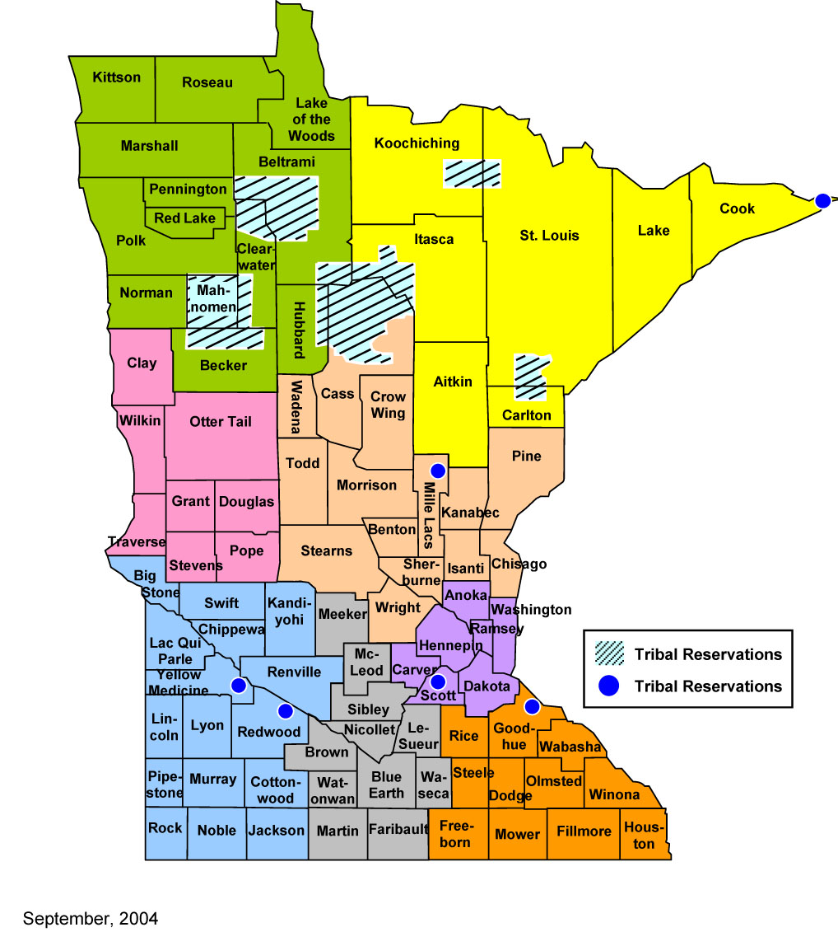

**See Appendix M for the color coded Regional Contact information**

# List of Appendixes

### Appendix A – CMS Emergency Preparedness Checklist for Effective Healthcare Facility Planning

### Appendix B – Facility Hazard Vulnerability Analysis

### Appendix C- Organization chart/Job Action Sheets/ICS Quick start guide

### Appendix D - Facility Contact Lists

### Appendix E - Facility Specific Information

### Appendix F– HIPAA Waiver Toolkit

### Appendix G - Evacuation Plan and Checklists, and Transportation agreements

### Appendix H - Facility Shelter in Place plan, Supply and Equipment lists, and checklists

### Appendix I – MOU templates

### Appendix J– Recovery checklists

### Appendix K – Staff Care Plan documentation

### Appendix L – Exercise, Evaluation, and Improvement planning checklist and AAR/IP

### Appendix M – Regional Contacts and Important Resources

### Annexes – Additional templates

#### Apartment Evacuation policy

#### Behavioral health – Psychological First Aid

#### Bioterrorism threats

#### Bomb Threat policy

#### Chemical Spills

#### Communications

#### Electrical power outage policy

#### Elevator policy

#### Emergency notification of Administrator

#### Fire policy

#### Heat & Humidity policy

#### Loss of telephone service policy

#### Missing person policy

#### Severe weather policy

#### Water shortage policy

#### Winter storm safety policy

#### Workplace Violence/Hostile event

**The attachments contained within the Appendixes and Annexes are considered templates. To make the documents facility specific, facilities will need to adapt the templates.**

**Appendixes and Annexes are maintained in a separate file source.**

# Acronyms

|  |  |
| --- | --- |
| AAC | After Action Conference |
| AAR | After Action Report |
| ADM | Alternate Dispensing Method |
| AHLS | Advanced Hazmat Life Support |
| AII | Airborne Infectious Isolation |
| ALS | Advanced Life Support |
| APR | Air Purifying Respirator |
| ARC | American Red Cross or Agency Review Committee |
| ASPR | Assistant Secretary for Preparedness and Response |
| BH | Behavioral Health |
| BHP | Behavioral Health Provider |
| BHPP | Bioterrorism Hospital Preparedness Program (discontinued - see HSPP) |
| BLS | Basic Life Support |
| BT | Bioterrorism |
| C/E | Controller & Evaluation Handbook |
| CAT | Chemical Assessment Team |
| CBHH | Community Behavioral Health Hospitals |
| CBRNE | Chemical, Biological, Radiological, Nuclear and Explosive |
| CDC | Centers for Disease Control |
| CGMO | Chief Grants Management Officer |
| CILS | Local Centers for Independent Living |
| CIP | Critical Infrastructure Protection |
| CMIST | Communication, Medical, Independence, Supervision, Transportation |
| COOP | Continuity of Operations Plan |
| CAP | Corrective Action Program |
| CPH | County Public Health |
| CST | Civil Support Team |
| DAB | Departmental Appeals Board |
| DBERT | Disaster Behavioral Early Response Team |
| DDS | Design and Development System |
| Decon | Decontamination |
| DEM | Department of Emergency Management |
| DHHS | Department of Health and Human Services |
| DHS | Department of Human Services or Department of Homeland Security |
| DMAT | Disaster Medical Assistance Team |
| DMORT | Disaster Mortuary Operational Response Team |
| DOC | Department Operations Center |
| DOT | Department of Transportation |
| DPS | Department of Public Safety |
| ECC | Emergency Coordination Center |
| ED | Emergency Department |
| EEG | Exercise Evaluation Guide |
| EH | Environmental Health |
| EM | Emergency Management |
| EMI | Emergency Management Institute |
| EMP | Emergency Management Plan/Program |
| EMS | Emergency Medical Services |
| EMSRB | Emergency Medical Services Regulatory Board |
| EOC | Emergency Operations Center or Environment of Care |
| EOP | Emergency Operations Plan |
| EP | Emergency Preparedness |
| EPA | Environmental Protection Agency |
| Epi | Epidemiologist |
| EPR | Emergency Preparedness & Response |
| EPs | Element of Performances |
| ERG | Emergency Response Guidebook |
| ERS | Emergency Response System |
| ERU | Emergency Response Unit |
| ESAR-VHP | Emergency System for the Advanced Registration of Volunteer Health Professionals |
| ESF | Emergency Support Functions |
| ExPlan | Exercise Plan |
| FCC | Federal Coordinating Center |
| FCO | Federal Coordinating Officer |
| FE | Functional Exercise |
| FLOP | Finance, Logistics, Operations, Planning |
| FPC | Final Planning Conference |
| FSE | Full-Scale Exercise |
| GETS | Government Emergency Telecommunications Service |
| GIS | Geographic Information System |
| GMO | Grants Management Officer |
| GPMRC | Global Patient Movement Requirements Center |
| FEMA | Federal Emergency Management Agency |
| HAM | Slang for Amateur Radio Operator |
| HAN | Health Alert Network |
| HAZMAT | Hazardous Materials Management |
| HC | Health Care |
| HCC | Hospital Command Center |
| HCF | Health Care Facility |
| HICS | Hospital Incident Command System |
| HERT | Hospital Emergency Response Training |
| HFP | Healthcare Financial Partnership |
| HHS | Health and Human Services |
| HPICM | Health Policy Information Compliance Monitoring |
| HPP | Hospital Preparedness Program |
| HRSA | Healthcare Resources & Services Administration (Grant dollars) |
| HRTS | Hospital Resource Tracking System |
| HSEEP | Homeland Security Exercise & Evaluation Program |
| HSEM | Homeland Security & Emergency Management |
| HSPD | Homeland Security Presidential Directive |
| HSPP | Healthcare System Preparedness Program |
| HVA | Hazard Vulnerability Analysis |
| HVAC | Heating, Ventilation & Air Conditioning |
| IAC | Incident Advisory Council |
| IAP | Incident Action Plan |
| IC | Incident Command or Infection Control |
| ICP | Incident Command Post |
| ICS | Incident Command System |
| ICU | Intensive Care Unit |
| IDDA | Intra-Departmental Delegation of Authority |
| IDEPC | Infectious Disease Epidemiology, Prevention and Control |
| IMT | Incident Management Team |
| IMS | Incident Management System |
| IP | Improvement Plan |
| IPC | Initial Planning Conference |
| IPG | Incident Planning Guide |
| IRG | Incident Response Guide |
| IT | Information Technology |
| ITV | Interactive Television |
| JAS | Job Action Sheets |
| JCAHO | (acronym no longer in use) The Joint Commission |
| JFO | Joint Field Office |
| JIC | Joint Information Center |
| JIS | Joint Information System |
| JOC | Joint Operations Center |
| JPIC | Joint Public Information Center |
| LEPC | Local Emergency Planning Committees |
| LHD | Local Health Department |
| LMS | Learning Management System |
| LPH | Local (county) Pubic Health |
| LRN | Laboratory Response Network |
| LTC | Long-term Care |
| MAC | Multi-Agency Coordination Center |
| MCHP | Minnesota Council of Health Plans |
| MCI | Mass Casualty Incidents |
| MDH | Minnesota Department of Health |
| MDS | Mass Dispensing Site |
| MERET | Minnesota Emergency Readiness Education & Training |
| MHA | Minnesota Hospital Association |
| MIMS | Minnesota Incident Management System |
| MLS | Minnesota Laboratory System |
| MN Trac | Minnesota system for Tracking Resources, Alerts & Communication |
| MMRS | Metropolitan Medical Response System |
| MOS | Measure of Success |
| MOU | Memo of Understanding |
| MPC | Mid-term Planning Conference |
| MRC | Medical Reserve Corps |
| MRCC | Medical Resource Control Center |
| MSCC | Medical Surge Capacity and Capability |
| MSEL | Master Scenario Events List |
| NBHPP | National Bioterrorism Hospital Preparedness Program |
| NDMS | National Disaster Medical Management System |
| NEXS | National Exercise System |
| NFPA | National Fire Protection Association |
| NGO | Nongovernmental Organization |
| NIC | NIMS Integration Center |
| NIEHS | National Institute of Environmental Health Sciences |
| NIIMS | National Interagency Incident Management System |
| NIMS | National Incident Management System |
| NIOSH | National Institute for Occupational Safety and Health |
| NoA | Notice of Award |
| NOC | National Operations Center |
| NRF | National Response Framework |
| NRP | National Response Plan (Obsolete) |
| ODP | Office of Domestic Preparedness |
| OEP | Office of Emergency Preparedness |
| OPHS | Office of Public Health and Science |
| OSCF | Off Site Care Facility |
| OSHA | Occupational Safety and Health Administration |
| PAPRs | Powered Air Purifying Respirators |
| PHEP | Public Health Emergency Preparedness |
| PCC | Patient Care Coordination |
| PEMS | Postal Emergency Management System |
| PFA | Psychological First Aid |
| PH | Public Health |
| PHIN | Public Health Information Network |
| PHL | Public Health Laboratory |
| PHNC | Public Health Nurse Consultant |
| PHPC | Public Health Preparedness Consultant |
| PICEs | Potential Injury Creating Events |
| PIO | Public Information Officer |
| PIS | Public Information System |
| POC | Project Officer |
| POC | Point of Contact |
| PPE | Personal Protective Equipment |
| PPR | Periodic Performance Review |
| PSA | Primary Service Area |
| PSAP | Public Safety Answering Point |
| PSAT | Patient Surveillance and Tracking |
| RBHC | Regional Behavioral Health Coordinator |
| RCC | Regional Coordinating Center |
| RCW | Regional Cache Warehouse |
| RDN | Regional Distribution Node |
| RFID | Radio Frequency Identification |
| RHRC | Regional Hospital Resource Center |
| RHPC | Regional Healthcare Preparedness Coordinator |
| ROC | Regional Operations Center |
| RPC | Regional Program Coordinator |
| RRCC | Regional Response Coordination Center |
| RSS | Receipt Storage & Staging Sites (part of SNS) |
| RTAC | Regional Trauma Advisory Committee |
| RTC | Regional Treatment Center |
| SAM | SNS Asset Management System |
| SC MN | South Central Minnesota (15 county area) |
| SEOC | State Emergency Operations Center |
| Sit Man | Situation Manual |
| SMART | Simple, Measurable, Achievable, Realistic and Task Oriented |
| SNS | Strategic National Stockpile |
| SOG | Standard Operating Guidelines |
| SOP | Standard Operating Procedure |
| T & EPW | Training & Exercise Plan Workshop |
| TCL | Target Capabilities List |
| TSP | Telecommunications Service Priority |
| TTX | Tabletop Exercise |
| UASI | Urban Area Security Initiative |
| UICC | Unified Incident Command Center |
| UMN | University of Minnesota |
| UTL | Universal Task List |
| VAMC | Veterans Administration Medical Center |
| VMAT | Veterinary Medical Assistance Team |
| VMI | Vendor Managed Inventory (part of SNS program) |
| VOAD | Voluntary Organizations Active in Disaster |
| VoIP | Voice over Internet Protocol |
| WC | Wheelchair |
| WMD | Weapons of Mass Destruction |
| WPS | Wireless Priority Service |