Attachment 4—Surge Operations and Crisis Care for Hospitals
Planning and Implementation Guidance
Month, Day, 2017

Preface
The Surge Operations and Crisis Care for Health Care Facilities Attachment is a guidance document designed to help health care facilities plan for shortfalls in the health care system during a surge incident. This guidance assumes incident management and incident command practices are implemented and key personnel are familiar with the ethical frameworks and processes which underlie scarce resource decisions as outlined in the State of Minnesota Crisis Standards of Care Framework.
During a Surge Operations and/or Crisis Care situation each health care facility or health care system will have to determine the most appropriate steps and actions for their entity based on their environment, hazards, and resources. Since pre-planned actions are always preferred to ad hoc decisions, pre-event familiarity with the contents of this Attachment and development of regional and local crisis standards of care plans is recommended to aid with event preparedness, response and in anticipation of specific resource shortfalls. This Attachment addresses common categories of health care delivery, triage, staff and space. Regional health care coalitions (HCCs), Minnesota Hospital Association (MHA), health care systems, and health care personnel may determine additional issues and strategies for their specific situation in addition to those outlined in this Attachment.
The Minnesota Department of Health (MDH) formed a Crisis Standards of Care Health Care Surge Workgroup in the fall of 2016 to review and provide input on crisis care issues and solutions for the wide range of Minnesota health care facilities. This Attachment would not have been possible without the diverse and practical input provided by the reviewers and advisors to this process; their efforts will benefit the citizens of the state. This Attachment is part of a larger process by MDH to document Crisis Standards of Care policies as well as engage the public in discussions about the ethics and principles of crisis care.
This Attachment constitutes the consensus recommendations of the Workgroup but does not represent policy of the MDH. Health care facilities or systems implementing these strategies in crisis situations should assure communication and coordination with their public safety, health care providers and local and tribal public health partners and emergency management to assure the invocation of appropriate legal and regulatory protections as appropriate in accord with state and federal laws. Recommendations within this Attachment may be superseded by incident specific recommendations by MDH. Web links and resources listed are provided as examples, and may not be the best sources of information available. Their listing does not imply endorsement by MDH.
This Attachment does not replace the judgment of the health care facilities’ operational management, medical directors, their legal advisors or clinical staff and consideration of other relevant variables and options during an event.

Introduction
Minnesota has over 130 hospitals ranging from critical access health care facilities with 25 beds to large academic medical centers with more than 1000 beds. These hospitals may be the only health care resource for many miles, providing necessary emergency and general inpatient services to their community or may be mere blocks away from another major tertiary medical center. As health care systems consolidate, services and available beds continue to shrink, thereby capacity within the system to respond flexibly to surges in demand.
Minnesota hospitals and other health care facilities are faced with a wide variety of potential large-scale incidents that could quickly tax or exhaust their resources. In some situations, the event may damage the health care facility itself, with major impact on the ability to maintain operations and serve the community. There is a significant risk for natural, man-made and terrorism-related disasters throughout the state. Pandemics such as H1N1 flu virus can have an impact on health care services statewide. Minnesota borders Canada in some of the most rural portions of the state creating cross-border issues, in addition to multiple international ports of entry on Lake Superior that serve oceangoing vessels. Highways and railways crisscrossing the state present substantial risk of hazardous materials and other transportation-related incidents. Minnesota also has two nuclear power plants, both located outside of the twin cities metropolitan area, which could potentially affect health care systems in the event of a radiological release at one of these plants. Unfortunately, the risk of terrorist attacks on targets small and large in Minnesota is substantial and must be planned for by all health care systems.
This document provides an overview of surge capacity and crisis care operational considerations for health care facilities with an emphasis on hospitals. In-depth discussion of the framework, ethics, and practical applications of crisis standards of care may be found in the 2012 Institute of Medicine (IOM) (now known as the National Academies of Medicine, Health and Medicine Division [HMD]—referred to as IOM/NAM throughout this Attachment) report including a specific section on Hospital care are available at The National Academies of Science, Engineering and Medicine, Crisis Standards of Care: A Systems Framework for Catastrophic Disaster Response. An additional document that may be of assistance is a card set designed for scarce resource situations (e.g., shortages of staff, medications) developed by the MDH Science Advisory Team (SAT) which is available at the Minnesota Department of Health, Patient Strategies for Scarce Resources Situations.
This Attachment is aimed at hospital operations and though it does detail the supporting role of state agencies it is the responsibility of the facility to apply this guidance with the help of their management team and medical staff to ensure operational plans are in place.

Crisis care
Most health care facilities are familiar with the concept of surge capacity, the ability to increase services to match demand. Surge capability is slightly different in that it requires specialized equipment or training to meet a patient’s specific needs – an example might be a contaminated patient or one with a highly infectious disease. This Attachment focuses on capacity, but a short section provides some basic guidance on specialty situations (pediatric, high consequence infectious diseases) that can push health care facilities into crisis care as well. Adequate supplies, training, and regional policies are just as important for capability as well as overall capacity.
For purposes of this Attachment, crisis care refers to the care and strategies at the facility level when demand acutely exceeds supply of resources and usual medical practices cannot be maintained. Crisis care situations can occur without warning when a no-notice event affects any health care facility, but usually can be addressed within hours by bringing in additional resources or transferring patients to other facilities.
Crisis Standards of Care refers to systematic support (including governmental) for non-traditional health care operations during a prolonged and widespread event that require declarations of disaster, legal and regulatory support, and issuance of clinical care guidelines (potentially including triage criteria) by state agencies recognizing the need for consistent statewide implementation of patient care strategies. Crisis Standards of Care would typically involve an extremely unusual and widespread event such as a severe pandemic.
In order to achieve a successful response, health care facilities must utilize an incident management system and attempt to move as rapidly as possible from a reactive posture (relying on frontline personnel utilizing job aids and applying their training) to a proactive posture (managing the event by objectives using an incident action plan). The Incident Management System (usually the Hospital Incident Command System [HICS]) must have the ability to integrate the appropriate medical/technical experts into the planning process and to inform the hospital Incident Commander (IC) about the specific needs of the event.
For example, critical care physicians or a clinical care committee to propose modifications to medical services provided and any necessary triage decision processes. The IC and administration should bear responsibility for assuring that they have obtained the appropriate expert advice (e.g., infectious disease input for Ebola protocols) and approve the policies and modifications to clinical practice whenever possible. They should not allow it to fall to the individual clinician to make such decisions.
Coordination with other health care facilities both internally and externally within the regional HCC is critical to assure that patients and resources are distributed to balance the demands of the event across as many facilities as possible and thereby diffuse the impact. Health care facilities should attempt to mitigate any crisis situation as soon as possible by transferring patients or bringing in resources. This should be done in coordination with HCC partners. Hospitals should be very familiar with the plans of their local coalition for response coordination and resource management.
Surge capacity strategies are not all equal. For example, some can be accomplished with minimal risk (e.g., using post-anesthesia care beds for temporary inpatient care) and some carry significant risk (e.g., providing cot-based care in flat-space areas such as classrooms). Maximizing surge capacity strategies that mitigate the crisis while minimizing the risks associated with deviations from conventional care is the goal. Choosing the strategies that are most appropriate to the situation and pose the least risk to the patient and provider, and then proceeding to riskier strategies as demand increases and options decrease is the preferred path.
Surge capacity is therefore divided into three categories across a spectrum (Figure 3.1):
Conventional – usual strategies and resources – e.g., maximizing bed occupancy, calling in additional staff to assist
Contingency – strategies and resources that may incur a small risk to patients but provide functionally equivalent care (e.g., using post-anesthesia care unit (PACU) beds for patient care using less traditional but appropriate resources).
Crisis – disaster strategies used when demand forces choices that pose a significant risk to patients but is the best that can be offered under the circumstances – e.g., cot-based care, severe staffing restrictions, or restrictions on use of certain medications or other resources.

Figure 4.1: Examples of health care facility conventional, contingency, and crisis care (modified from IOM/NAM 2012)
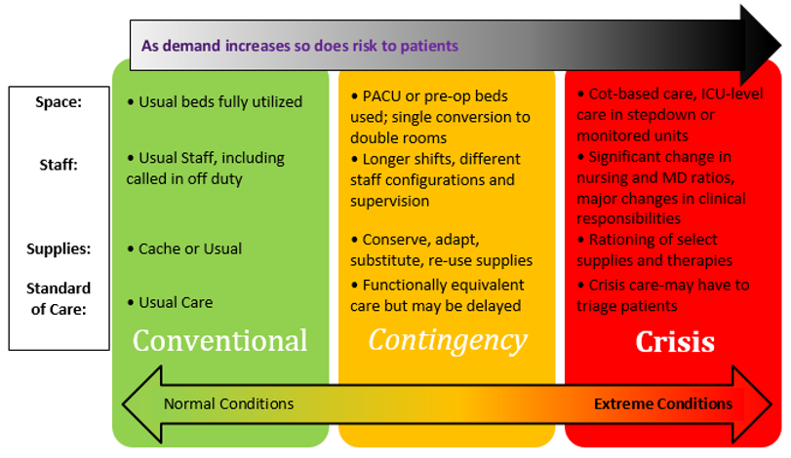

Key points about crisis care:
Crisis care is not a separate triage plan; these strategies are extensions of surge capacity plans.
Crisis care may occur during long-term events such as pandemics when no reasonable help is expected, or during short-term, no-notice events where help will arrive, but too late to solve an acute resource shortfall.
Health care facilities will not have an option to defer caring for patients in a crisis situation; demand will drive the choices that have to be made.
If strategies are not planned for ahead of time, they likely will not be considered and/or will be difficult to implement.
Strategies should be proportional to the resources available; as more resources arrive, you should move back toward lower risk strategies (and therefore, back toward contingency and eventually conventional status).
It is MDH’s view that crisis care planning must be integrated into all-hazards plans at all levels of health care planning. Local and state government, including agencies such as MDH, support those responses through declarations and legal and regulatory mechanisms. These may include care guidelines or declarations of Crisis Standards of Care, as required.

Roles and responsibilities
Though the primary focus of this guidance is on the operational strategies for health care facilities during crisis, health care facilities should be supported by local health care coalitions and state and local government agencies. Health care coalitions includes partnerships between local public health, EMS, health care facilities, and emergency management that provide planning and response coordination in each of eight regions of the State. A brief outline of key roles and responsibilities as related to the activation of the CSC Framework is in the Roles and Responsibilities Table 2. Surge Capacity

Emergency department space
A location, staff, and basic supplies (ideally packed in bins, pre-event) for overflow care of people with minor wounds, as well as one for family reunification should be planned. Additionally, if there are clinics, supervised living facilities or nursing homes connected to or close to the health care facility, they should be part of the surge capacity plan. Upon activation of the disaster plan, the ED should be cleared to the degree possible by discharging, moving patients to inpatient beds, moving patients to observation areas, and moving stable patients back out to triage as rapidly as possible depending on available space. Inpatient units should be ready to accept patients to decompress the ED, bypassing usual processes. Transfer of patients to other hospitals can also assist with space creation. This may occur by ground or air and by many transportation options (ambulance, bus, private vehicle) as the situation warrants. Although the hospital likely has established referral patterns, other options should be examined in a crisis.

Space – floor space
Conventional beds should be filled and staffed to capacity. The health care facility should know which single rooms can accommodate an additional bed and keep adequate beds in supply to the degree possible to allow for double rooming. Adequate headers (oxygen, suction, electrical) and privacy curtains are important considerations when planning to double rooms. Additional observation beds, procedure areas, and flat spaces may be used. The health care facility should maintain adequate cots (with egg-crate or other mattresses) to use in flat-space areas for crisis care (also helpful for staff during blizzards and other situations). Patients should be carefully evaluated before being moved to these areas (normal mental status, low risk for pressure ulcers, not in isolation for infection control purposes etc.)
A “surge discharge” process should occur as soon as the EOP is activated. Charge nurses should identify patients that are appropriate for early discharge and move them to a discharge holding area or the hallway/unit waiting area for physician review. This can open up rooms rapidly. If not appropriate for discharge, the patients moved may be appropriate for cot-based care.
When not needed for intensive care unit (ICU)-level care, pre and post-op (i.e., PACU) areas may be used for floor care as well if available. If use of surge areas such as PACU or cot-based care are anticipated beyond the first 24 hours for inpatient care, HCC partners should be engaged to assist with accepting transfers and other support. If other area’s health care facilities are in the same situation, the request of a Centers for Medicare and Medicaid Services (CMS) 1135 waiver should be considered to allow billing for patient care in these areas (see Legal section below).
The health care facility surge plan should include a grid that demonstrates the strategies/areas that will be used for conventional, contingency, and crisis care for quick reference. An example is available in Table 7-2 of the 2012 IOM Crisis Standards of Care Report.

Space – intensive care unit
For planning purposes, ICU services should include the ability to provide cardiac monitoring, invasive monitoring, mechanical ventilation, and hemodynamic management (e.g., pressor medications). Many facilities do not provide these services, although at a minimum, they should be able to provide initial resuscitation and management awaiting transfer to another facility. In certain situations, due to capacity or weather, a health care facility that normally refers critically ill patients may have to continue to provide care for hours to days longer than usual or may elect to provide ongoing critical care using transport ventilators and other resources. In these cases, critical care consultation should be obtained via phone or telemedicine to provide expert input on the care provided until transfer can be arranged or critical care is no longer required.
The American College of Chest Physicians has guidance documents on ICU surge published in 2014. The executive summary with all the suggestions can be found at Introduction and Executive Summary Care of the Critically Ill and Injured during Pandemics and Disasters: CHEST Consensus Statement. Each of the sections has a supporting article (e.g., surge capacity logistics) with further details.
According to the key recommendations made by the American College of Chest Physicians, hospitals that provide inpatient critical care should be able to:
Surge 20% of usual ICU capacity within hours;
Surge 100% of usual ICU capacity within 24 hours using facility or regional HCC assets; and
Surge 200% of usual ICU capacity within days using regional HCC, state, or federal assets.
In order to accomplish this, health care facilities that provide ICU services should determine the spaces of the hospital that could be used for ICU level care. In particular, procedural and surgical areas including pre and post-op care areas are likely targets as they may already have the monitoring equipment necessary for critical care. The health care facility may wish to create a grid for ICU surge similar to that for floor beds indicating the sequence/preference and numbers of beds (as well as additional supplies needed for those areas) to be used. Additional information on planning for ICU surge has been published in Chest including principles and logistics.
Though planning for a 200% surge is daunting, most facilities will find they have adequate space, and can document the specific additional logistical (staff and supply) needs that may be requested if required. This would primarily occur in a pandemic event, but potentially in other scenarios where the health care facility cannot off-load patients rapidly (e.g., large scale anthrax or botulism attack). Few hospitals will have the ventilator and may not have the cardiac monitor resources to achieve a 100-200% surge, but understanding the needs and planning for it is critical to being able to request the necessary assets in a timely manner from regional and Federal sources.
Inherent in the ICU surge plan is an understanding that the overall acuity at the health care facility will increase markedly, and that lower acuity patients may need to be discharged to outpatient care referred to homecare, long-term care, or provided care at an alternate care site. This may necessitate changes in discharge protocols and health care facility policies about what patients will be cared for on what units.

Space – alternative care sites
In addition to maximal utilization of usual ambulatory care sites, homecare, and hospitals alternate systems of care including telehealth services or screening and early treatment sites may be needed to meet the demands of a crisis incident. Alternate Care Sites (ACS) are developed to accommodate overflow hospital capacity. By providing care to less complex inpatients, an ACS can free up hospital capacity for patients in need of more intensive care. During an incident, a hospital may establish an on-site ACS or a community site may be established and work in conjunction with the local health system (via multi-agency coordination) to staff and triage appropriate patients to the facility. Examples of some services available at an ACS may include oxygen, intravenous fluids, medications, and basic laboratory testing. Critical care services are generally not available. Health care services must also be made available at community shelters including resources for those with chronic illness.
Alternate systems of care should be implemented by health care coalition partners as part of a regional strategy to address incident demands and may include virtual as well as physical patient contact and interventions.

Staff
Availability of appropriately trained staff is a key limiting factor in disaster response. Health care facilities should have plans and mechanisms to notify and call back their staff, as required, during an incident. In most no-notice scenarios, a brief period of inadequate staffing is followed by too many available staff.
Longer events, such as pandemics, where staff are taxed for long periods of time and absenteeism may be high due to personal or family illness are of particular concern. The Incident Commander should direct the hospital ICS Planning Section to engage appropriate experts to determine what services will be prioritized and direct appropriate staff to provide those services. This could include the use of a multi-disciplinary Clinical Care Committee if resources allow; see IOM/NAM report 2012 section 4-5. For example, clinics may be cancelled to allow staff to participate in inpatient care, specialty clinics might be cancelled to allow additional rooms to see ill ambulatory patients and decrease ED volumes.
Such decisions require careful balancing of the usual medical needs of the community and the demands of the incident, so that patients with acute conditions unrelated to the incident can still be seen and evaluated and issues that do not absolutely require a patient visit (e.g., medication refills) can be addressed using alternative means. Further, staff and others may be asked to contribute to patient care in novel ways (e.g., office staff or family members may provide non-medical care and feeding to the patient, allowing nurses to focus their expertise on medication administration and other patient management, clinic hours may be extended, and electronic visits may substitute for in-person visits).
In some cases, just-in-time training may be used to broaden staff skills, but tasks still need to be delegated appropriately and within scope of practice. For example, staff most able to manage ventilators are registered respiratory therapists. In order to alleviate respiratory therapist workload and allow them to focus on ventilator management, nurses can administer nebulized medications and perform other respiratory care duties within their scope of usual practice. Additional guidance on staff shortages may be found in the SAT Scarce Resource card set can be found at Patient Care Strategies for Scarce Resources Situations.

Supplies
A wide range of supplies may be needed during an emergency or disaster depending on the type and duration of the incident. Due to current just-in-time supply policies, shortages of supplies are likely without proper planning. Increasing par levels of selected medications and supplies can be critical to accommodate a surge in demand. Consideration should be given to placing beds, monitors, and ventilators that are going out of service into storage rather than selling them whenever possible, as these high-cost items are not likely to be available from vendors during an emergency or disaster. Depending on the institution, purchase of some of these items may be possible.
For most hospitals, concentrating on inexpensive but commonly needed supplies such as intravenous fluids, airway supplies, wound care supplies, and medications for analgesia and sedation will provide the highest return on investment when planning for disasters. Additional information on medication, IV fluid, oxygen, and other supplies is available in the SAT Scarce Resource card set.
When supplies are inadequate, a structured approach should be used involving:
Conservation
Substitution
Adaptation
Re-use
Re-allocation
Medication shortages are common occurrences and allow health care facilities to practice crisis care strategies by using incident management frameworks and engaging SMEs (physicians in the specialty area, pharmacy staff, administration, nursing) in the decision-making process as they cope with dynamic and multiple medication shortages.
During an incident, when levels of supplies (e.g., PPE) or medications are inadequate, and the supply chain and HCC partners cannot provide relief, the facility’s ICS Planning Section should convene appropriate SMEs to look at existing guidance and develop facility recommendations (note that this can also be done at the health system and regional level as needed). If broader resource challenges are present, the Planning Section or hospital Incident Commander, may ask a Clinical Care Committee to convene in order to assist with addressing service, supply, and staff practices. They can help to focus the facility resources on patient care and make recommendations for any necessary triage of services. For example, discontinuing provision of high-intensity services such as extra-corporeal membrane oxygenation (ECMO) when the resource commitment is unsustainable. Detailed information about the membership and function of the Clinical Care Committee is available in the IOM/NAM 2012 document referenced above and in the template Crisis Care Facility Plan in Appendix 4.1.
In an extreme situation, re-allocation of resources may be necessary (i.e. taking a resource from one patient to give to another). In this case, the gravity and complexity of the situation is markedly increased and the health care facility should have a formal Crisis Care Triage Plan to refer to (see Appendices 4.1 and 4.2 for examples). Note as ECMO is used more frequently, the available capacity is very limited and may have to be triaged, even during significant seasonal influenza years.

Special considerations/capabilities
Certain populations or categories of illness and injury require specialized responses. The health care facility should have appropriate equipment to initially assess and manage emergent needs while awaiting transfer or admission during a surge incident. There are many categories, but a few are worth highlighting, as an unprepared facility poses a risk to both providers and patients. Regional planning, training, and exercising for these specialty situations is strongly encouraged. During an event, HCC support for affected facilities can be critical to avoiding or reducing crisis care situations.

Hazardous materials and decontamination
Hospitals should be prepared to provide decontamination services to arriving patients including wet and “dry” decontamination (dry decontamination = disrobing with redress kits). Dry decontamination may be supplemented by skin wiping (see PRISM guidance at Medical countermeasures.gov, Decontamination Guidance for Chemical Incidents. Provider PPE and training should conform to OSHA Best Practices for Hospital Based First Receivers of victims from Mass Casualty Incidents Involving the Release of Hazardous Substances. Health care facilities should be prepared for large numbers of patients with inhalational exposures following transportation and fixed-facility incidents that may, at minimum, require dry decontamination.

Pediatrics
Every acute care health care facility should have trained personnel and equipment available to manage pediatric emergencies. Additionally, HCCs should have pediatric plans in place that the facility should be aware of. Plans for a pediatric safe area, patient tracking, and on-site surge or transportation plans should be in place. In some situations, the facility may have to hospitalize pediatric patients due to pandemic or weather-related events. The Minnesota Pediatric Surge Primer and Template Plan provides templates and specific planning information for pediatric mass casualty events.

Burns
Every acute care hospital should have trained personnel and equipment available to provide initial management to burn patients. Health care facilities should plan to stock analgesia and basic dressings according to their size and the HCC expectations and should notify their RHPC as well as their usual burn center partner immediately of a mass burn event. The Metro Mass Burn and Minnesota State Burn Surge Plan may need to be activated when Hennepin County Medical Center and Regions Hospital Burn Centers exceed capacity in which case excess burn casualties may be boarded at Burn Surge Facilities. Burn Surge Facilities are usually regional trauma centers. Additional burn educational and planning materials are available from MDH’s Center for Emergency Preparedness and Response (EPR) Minnesota Burn Surge.

High consequence infectious diseases
Health care facilities should have a screening process for fever and international travel that can be updated for domestic exposures and specific countries as required by current epidemics/pandemics. All hospitals should have a plan to provide airborne isolation to suspect cases of tuberculosis (TB), Severe Acute Respiratory Syndrome (SARS)/Middle East Respiratory Syndrome (MERS), variant influenza, and more “usual” diseases, such as measles. Appropriate stocks of N95 masks and barrier precautions should be available with regional strategies for larger events. A regional plan should be in place for initial transportation, screening, and referral to further evaluation for any patient with suspect Viral Hemorrhagic Fever (e.g., Lassa fever, Ebola virus disease) symptoms. The PPE and training for these cases is intensive and requires ongoing commitment to assure provider and patient safety. The biggest danger with suspect viral hemorrhagic fever cases is that a patient with possible symptoms - but without the disease - gets inadequate care and has a poor outcome due to provider reluctance to give care. Health care facilities should assure that appropriate mechanisms are in place to provide initial screening and stabilization care and referral as required based on the level of suspicion. EMS should have protocols on the safe transport and identified destination facilities for suspect cases. For further reference, please see Minnesota Collaborative for Health care Response to Ebola Conceptual Framework and Collaborative Charter.

Planning and implementation - general

Indicators and triggers
An “indicator” is a predictor of a possible surge event (e.g., a tornado warning, report of several cases of unusual respiratory illness) that requires gathering of additional information or analysis to decide if a “trigger point” (threshold) has been reached to take action.
There are two types of triggers. Scripted triggers are built into standard operating procedures and are automatic ‘if/then” decisions. Whenever possible, scripted triggers should be developed for frontline personnel (e.g., point of entry health care facility staff, reception, etc.) so they have actions they can take immediately to prevent delay. Non-scripted triggers require additional analysis and consideration involving supervisory staff. These are often part of an incident action planning cycle. The less specific the information available, the more difficult it is to apply a scripted trigger and the more likely an experienced supervisor or subject matter expert (SME) will be involved to process the information and decide on necessary actions. Front line personnel —like an Emergency Department nurse—should have a low threshold for passing indicator information along to supervisors for situational awareness and potential decision-making.
Rather than focus on indicators and triggers in isolation, the facilities should determine what response strategies or options it may employ in a disaster. Then the facilities should decide on indicators that might be available and a trigger point for staff to take action. Though this may sound complex, it is simply establishing thresholds. A tornado warning, while an indicator, does not trigger disaster related actions. A report of a tornado touchdown in a populated area with multiple injuries should generate specific actions by hospital staff (disaster plan activation).
Standard Operating Procedures (SOPs) should specify when personnel take certain actions (e.g., activate disaster plan for event likely to generate >10 casualties). This is critical to the success of the response. Delays in decision-making occur in unfamiliar situations and with unclear authority. If a clear SOP is in place, the trigger will be automatic.
Triggers are important at every level of response from local to state to federal and the thresholds may vary (e.g., the threshold for a local disaster declaration is different than for a Federal declaration). Detailed information on indicators and triggers (including templates for health care facilities in Table 8-1) is available in the 2015 IOM/NAM report.

Out-of-hospital plans
Clinics and ambulatory care centers can provide critical outpatient capacity during pandemics, epidemics, and may be called upon to broaden their scope of care during other protracted events or when health care infrastructure is damaged in the community. These activities should be coordinated with local hospitals and the health care coalition to promote consistency and coordination of care. Clinics should examine their resources and determine potential contingencies such as:
Extended hours
Conversion of space and staff from specialty care to primary care duties
Changes to charting and administration to enhance flow (template charts and prescriptions for the event)
Changes to scheduling (e.g., cancel or re-schedule elective procedures and appointments)
Enhanced use of tele-medicine or telephone prescribing
Adjust clinic flow to avoid exposing well persons to ill persons
Communicate and implement guidance on scarce resources (e.g. guidelines for prescribing anti-viral medications or administering vaccine)
Homecare and hospice agencies may need to accommodate much sicker patients who have been discharged from hospitals that are concentrating efforts on critical care. These agencies will need to prioritize patients and caregivers, considering whether certain patient needs can be met with less skilled personnel, fewer visits, or less intensive support in order to successfully manage workload. The use of volunteers to provide check-in and other services may be helpful, as may telephone and other contact with clients. Agencies may not be able to spare workforce to assist with vaccination campaigns and alternative providers may need to be trained to provide the vaccinations, freeing homecare personnel for other, more specialized duties. Coordination with health care coalition planning and response activities can help balance staff and resource demands and promote consistency of response across multiple agencies.

Hospital plans
Hospitals should look at their resources (space, staff, supplies—described in more detail below) and determine their strategy options across the surge capacity continuum from conventional to crisis care as well as looking at specific capabilities in trauma care, critical care, HAZMAT, infectious disease, burn, and pediatrics to meet their objectives. This should be a joint effort involving nursing, administration, emergency management, emergency services, support services (e.g., lab, radiology, respiratory therapy, pharmacy) and physician personnel (as well as surgery and critical care if provided by the institution). Members of the HCC and regional EMS program should be involved to vet the plan when possible, ideally when still in draft form. Indicator and trigger thresholds for crisis care should be determined whenever possible (e.g., crisis status exists when any cot-based care is provided or any ICU care is provided outside usual intermediate and pre/post op areas). These triggers will vary by facility depending on size and resources. Additionally, the institution should decide, based on its role in the community and the presence or absence of other health care facilities in the area what number of general or specialty mass casualty patients will be planned for based on suspected hazards. For example, a critical access hospital might prepare for up to 10 total casualties with up to 5 being small children, whereas an urban Level 1 trauma center might prepare for up to 100 significantly injured patients, with up to 20 small children.
Once the indicators and triggers have been determined, the surge capacity information (including crisis care) should be written into the health care facility emergency operations plan (EOP) to give personnel clear expectations of what they will do and when they will do it. It should also include the notifications to supervisors and partner agencies that need to occur when these triggers are activated. Delegating authority to activate the disaster plan to Emergency Department staff or nursing supervisors/charge nurses should be done when possible to facilitate rapid action. The adoption of clear policies helps facilitate decisions as well as provides accountability.
Education, training, and exercising should be conducted to assure successful implementation of the plan. Job aids such as brief task cards should be widely used to help front line personnel with initial decisions and actions. During an event response, the facility should review and modify their procedures as needed as part of the incident action planning process. Plans should be flexible to not “lock in” disaster response protocols for the duration of an incident but allow flexibility and transition toward conventional care as more resources arrive or demand falls, or both (i.e., do not keep triaging resources when you have enough available).

Provider engagement
Health care providers must clearly understand the rationale for crisis care planning, the ethical principles underlying triage decisions, and the specific plans of the institution. Staff should be divided into tiers for education (e.g., knowledge, competency, proficiency) about the specifics of the crisis care plans based on their role in the response. For example, a floor nurse should understand how the surge plans affect their unit, including use of cots and changes in staffing). A nursing supervisor should understand when to activate crisis care plans, and who to notify that this is occurring. Staff who are fulfilling incident command roles should understand the interface with the health care coalition, where to get help or expertise, and be prepared to adopt proactive crisis care strategies with input from subject matter experts. It is critical that providers who may be called upon to make reactive triage decisions (e.g., emergency medicine physicians, trauma surgeons) understand not only the ethical principles, but which criteria may be ethically considered when making triage decisions. Examples of criteria to consider may include, prognosis, duration of use, the amount of resources likely to be used, and the duration of benefit. For more detail on ethical decision-making during a crisis care situation or activation of the Minnesota CSC Framework, please reference Attachment 1—Ethical Guidance for Crisis Standards of Care.

Exercises
Though it is difficult to fully exercise crisis care situations, providing table-top and other opportunities to walk through the process will help administrators and clinical staff become more comfortable with their roles and responsibilities relative to crisis care and will help drive modifications of existing plans. Exercises should also test the interface with the regional health care coalition to emphasize that under no circumstances should a health care facility be providing crisis care without reaching out for assistance from partner facilities.

Integration with regional operations
Minnesota is divided into eight health care preparedness program (HPP) regions, each of which has a health care coalition (HCC) consisting of leadership from health care facilities, EMS, public health, and emergency management. Each region has a Regional Health Care Preparedness Coordinator (RHPC) who works primarily with the health care facilities and EMS, and a corresponding Public Health Preparedness Consultant (PHPC) who works with local and tribal public health agencies. The RHPCs and PHPCs have direct communication with the State Health Department. For information on your local coalition please reference the map and contact information at: http://www.health.state.mn.us/oep/healthcare/coalitions/index.html
It is critical that health care facilities do not work on surge and crisis care plans in isolation, but in concert with their regional partners and with their parent health systems, as applicable. Consistency of plans and knowing what other health care facilities in the region are planning is critical to success. Surge strategies and standard procedures do not have to be identical, but if they are similar, it will help greatly in education, training, and mutual aid response. HCCs help coordinate not only planning, but also response activities. During a response, the HCC assures information sharing between health care facilities, EMS, and public health and provides support for and between disciplines in the area including resource management support (e.g., facilitating resource requests for staff or supplies between health care facilities). They can also engage with neighboring coalitions and the State (MDH/EMSRB) to coordinate information and strategies. HCC members interface with emergency management to assure that resource requests are met through established processes and a common operating picture is maintained. They may also convene workgroups during planning or a response to help develop regional tactics (e.g., to support alternate care sites or processes during a response or develop common policies such use and conservation of N95 masks).
The key is to only implement crisis strategies when assistance from regional partners is inadequate (either too little or too late) and no “bridging” therapies or patient transfers can address the need. Assuring regional coordination and leveraging of available resources prevents inappropriate transition to crisis standards of care. Coordination with the regional partners must be achieved as soon as possible when a crisis situation develops so patient care can return to conventional operations as soon as possible. The sooner a crisis situation is recognized (indicators), pre-planned resources and coordinating mechanisms are activated (triggers), and then the shorter the crisis period will be. The goal of emergency planning, and having good surge capacity plans is to avoid provision of crisis care. Detailed information about hospital surge capacity planning is beyond the scope of this Attachment but some key areas connected to crisis care are highlighted below.

Figure 4.2: Relationships
Figure 4.2a demonstrates the relationships between the Health Care Coalitions, health care, EMS, public health, tribal health, government, and non-governmental partners.
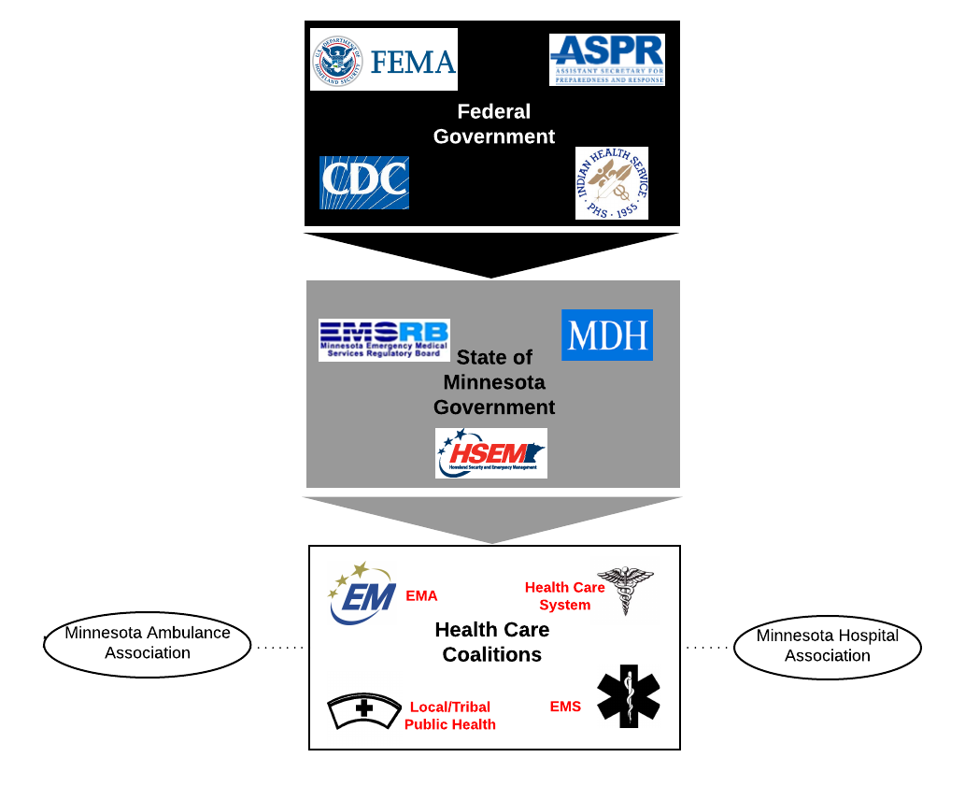
As for the MDH All Hazards Plan, MDH will use the National Incident Management System (NIMS) as a basis for supporting, responding to, and managing Plan activities. Incidents and events are managed at the lowest possible geographic, organizational, and jurisdictional level using NIMS. A key element of NIMS is the Incident Command System (ICS). ICS is a fundamental standardized form of management that provides a common organizational structure. Here at MDH, we organize our responses to an incident or event using ICS.
NIMS also stipulates that all disasters are local. On this note, all disasters will first be addressed on a local level with local/Tribal Public Health, the local EMS, the local Emergency Management Agency (EMA), the local health care systems, and finally the regional health care coalition (HCC). Each of the eight public health regions in the state has a health care coalition established for health care emergency preparedness and response coordination. HCC membership includes hospitals and other health care entities, jurisdictional emergency management, local and tribal public health, Emergency Medical Services and additional members such as behavioral health, dialysis centers, federal health facilities and long-term care. The coalitions engage members through regular meetings, training opportunities, exercises and all-hazards planning.
When resources and capacity are reached at a local level, response entities will go to the State and when State capacity and resources are reached the federal government will become involved. Federal resources and assistance will all be coordinated through the state. The only caveat to this is that Tribal Nations, as sovereign entities may request disaster assistance directly from the federal government.

Figure 4.2b: Hospital process diagram
Figure 4.2b is a hospital process diagram that facilities would use in a crisis standards of care situation much like the planning P used in ICS to help guide the process and steps involved in responding to an incident.

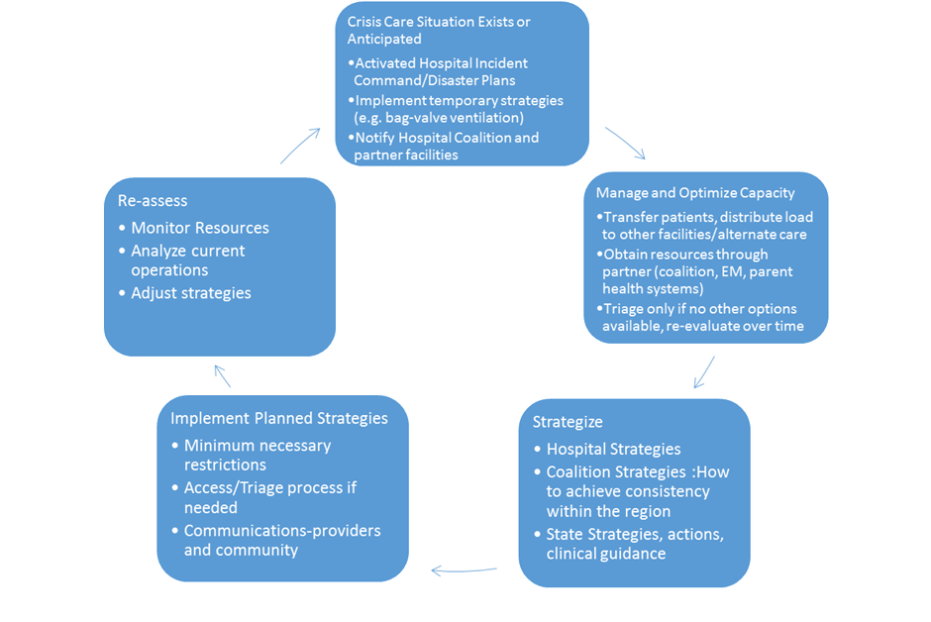

Triage

Framework
Triage generally refers to prioritization for care or resources. For example, emergency department patients are triaged for placement in the department based on their acuity. In rare situations, a lack of resources may require a more difficult type of triage that requires re-allocation or denial of a specific treatment, which may be prioritized based on prognosis or risk. For example, a patient without risk factors for complicated influenza may not qualify for anti-viral medication. Or, in a more extreme event, a patient might not be able to receive critical care due to their poor prognosis. This type of triage, performed after initial stabilization or during ongoing care (and in comparison to others that need the resource) is termed tertiary triage.” Frameworks are available for this type of burn and critical care triage and in the MDH Scarce Resource Card set noted prior.
More important than any clinical frameworks are the plans and process for tertiary triage decisions at the facility level. A triage plan should involve SMEs informing the Incident Commander and Planning Chief, likely through a Clinical Care Committee. This is mainly an issue at larger facilities providing ICU care. In situations where this type of triage is required during a protracted incident, MDH will provide guidance and convene the Science Advisory Team (SAT) to provide recommendations. The SAT/CSC is an expert group of clinicians that provide clinical recommendations to the commissioner regarding resource allocation and triage. For example, they were convened to work on re-use and conservation protocols for N95 masks during the H1N1 pandemic.

Ethical considerations
The accompanying Ethics Attachment (see Attachment 1—Ethical Guidance for Crisis Standards of Care) to the Minnesota Crisis Standards of Care Framework provides a comprehensive overview of considerations for providers. Providers and health care administrators should be familiar with that document and potential resulting conflicts and pitfalls that can be made. In general, triage decisions must meet the five basic requirements outlined in the IOM/NAM 2012 publication:
- Fairness—process recognized as fair, equitable, evidence based, and responsive to specific needs of individuals and the population focused on a duty of compassion and care, a duty to steward resources, and a goal of maintaining the trust of patients and the community.
- Transparency—in design and decision making
- Consistency—in application across populations and among individuals
- Proportionality—public and individual requirements must be commensurate with the scale of the emergency and degree of scarce resources (i.e. the restrictions on care should not be more restrictive than the situation requires – and this may require re-evaluation as more resources become available).
- Accountability—of individuals making the decisions and of the facilities and governments to support the processes and the providers.

Reactive triage
Reactive triage occurs in the early phases of the incident where the situation and information are fluid and the physicians and nurses will have to prioritize access to care and treatments based on their best judgment.
Mass casualty triage after a no-notice event is reactive, as it is performed based on limited information about the event, in a dynamic resource environment, and is usually performed by a single experienced provider. Generally, patients with altered mental status, signs of shock, penetrating torso injury, uncontrolled bleeding, and respiratory distress are highest priority. It is rare to have to categorize patients during this process as expectant (and therefore to receive palliative care as their only intervention) but this is possible in an overwhelming situation.
Factors to consider:
Time required to perform treatment
Treater requirements (i.e., how much physician/nursing expertise is required)
Treatment requirements (what are the resource requirements)
Prognosis of the injury—for example, elderly patients with massive burns, patients in severe traumatic shock with torso injuries at a hospital that does not provide surgical services, patients with severe coma (e.g. GCS = 3) immediately after trauma at a center that does not provide neurosurgery should take lower priority than patients with more favorable injuries/illness.
In general, the more victims there are, the more that the triage process should prioritize the moderately injured that require interventions (e.g. chest tube, airway management, and tourniquet) that will save their life and can be rapidly performed. It is always critical to re-evaluate patients as more resources arrive, however, as patients should always receive resources when they are able to. Finally, if multiple patients present with identical prognosis to a hospital that has minimal resources, a first-come, first-served or lottery strategy may have to be implemented.

Proactive
Proactive triage may be required later in an incident that continues to overwhelm the health care system after initial stabilization and delivery of available resources. The situation and resources are now known. Decisions revolve around whether resources can continue to be expended given the patient prognosis. A systematic approach should be taken that considers available evidence, resources, and has administrative backing of the facility.
Proactive triage of resources should only occur when the following conditions are met and unless specified otherwise, the patient should continue to receive all other means of support. The patient should always have equitable access to medications to control pain and suffering to the degree possible given the circumstances:
Proactive triage conditions to meet:
Critically limited resource(s) and infrastructure are identified.
Surge capacity is fully employed within health care facilities (and regionally) if capacity/space is the limited resource.
Maximal efforts to conserve, substitute, adapt, and reuse are insufficient if supplies are the limited resource.
Regional, state, and federal resources are insufficient or cannot meet demand.
Patient transfer or resource importation is not possible or will occur too late for bridging therapies (such as bag-valve ventilation or other temporizing measures) to be considered.
Necessary resources have been requested from local and regional health officials (as applicable).
A state of emergency has been declared, or other health powers (as applicable) have been activated.
Once a proactive triage situation is recognized (trigger) or anticipated (indicator) the facility should assure that a triage process is in place. The triage process is far more important than the specific clinical decision tools, which may vary based on the event. The facility can expect to receive guidance on decision tools from MDH during an emergency in which proactive resource allocation would be required on a large scale. The Clinical Care Committee/SMEs must provide a process and agree on indications for treatment (e.g., specific medications) or approve decision tools for triage of ICU and other resources.
If required, a triage team (usually clinicians not directly responsible for the care of the patient) should be available for consultation. This function may be provided regionally and remotely depending on the regional plan. For example, health systems may provide this function for all their health care facilities and the same team may provide assistance to outside health care facilities that wish to refer patients or do not have the resources to effectively make triage decisions. This would be a very unusual situation mainly limited to a severe pandemic though limitations on interventions like ECMO could be subject to regional shortages on a more frequent basis and may require similar processes – optimally implemented on a regional basis by those institutions providing these services.

Figure 4.3: Triage tree example
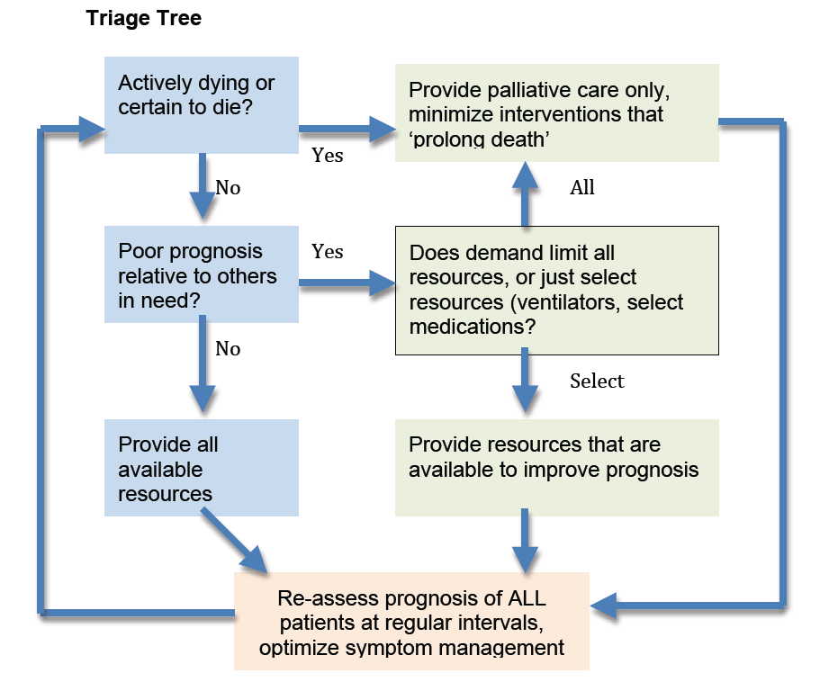
An additional, more detailed example of a triage plan can be found in Addendum 4.2. HCC activities during crisis care event will be robust, as the goal is to maintain a consistent level of clinical care within the region. Resource allocation, alternate care strategies, policy development, and agreeing on regional decision tools are all roles for the health care coalition members during an event.

Legal and regulatory considerations
Local, state, and federal agencies can provide support for crisis operations through a variety of mechanisms in addition to obtaining resources and providing guidance and policy directives for responders. A variety of legal and regulatory actions can be implemented during disasters that can facilitate payment, reduce liability, and permit response activities that would not normally be allowed without a disaster declaration. The ability of the Governor of Minnesota and the President of the United States to issue emergency declarations and promulgate enforceable orders and rules to address the contingencies created by a mass casualty event are provided by law. Some of the more important State and Federal laws that may apply to the preparedness for, response to, and recovery from an emergency or disaster are summarized in Attachment 2—Legal Authority and Environment for Crisis Standards of Care.
Tribal and territorial areas are independent legal entities, and though they interface with surrounding jurisdictions, they are self-governing and have the ability to make and enforce their own laws and rules. Tribes are also allowed to directly seek Federal assistance though in most cases they will also interface with the State as resources are often available more rapidly through local and State channels than Federal.

Statutes and ordinances
Agencies that issue rules, such as the Minnesota Department of Health and the EMS Regulatory Board have their authorities and some enforcement actions in statute (law). Laws are more difficult to modify, even in times of emergency. Rules, on the other hand, are more easily suspended. In relation to health care facilities, the Commissioner of Health maintains authority to implement provisions of Minnesota’s mass dispensing laws (Minn. Stat. §151.37, Subd. 2(b)) if the commissioner finds such action necessary to protect the public health and safety and provides for broad authority and protections in the types, use and administration of those medical interventions. It is possible a health care facility, or other acute care setting might be utilized as a point of distribution (POD) in an emergency and health care facility personnel, including emergency managers, lawyers, and staff will need to know what their role will be in this situation. Additionally, specific State rules and regulations governing hospital operations may be waived if the suspension of these would facilitate crisis care strategies. Provider licensing requirements may be adjusted or suspended, by the respective boards, to allow out-of-state and other providers to practice, or to allow an expansion of scope of practice. For example, prescribing exemptions or allowances for providers to administer vaccinations they are not normally licensed to provide.

Liability
A catastrophic disaster which causes activation of the CSC Framework may raise legal and liability concerns among health care and public health professionals due to their potential liability risk when extreme service demands, coupled with constrained supplies and diminished personnel, prevent provision of usual services and care expected by the community. Although lawsuits resulting from emergency planning or services rendered during an emergency or disaster are rare, responders may nonetheless be comforted in knowing what laws currently exist that might afford protections against lawsuits that might be leveled against them for actions undertaken – or not undertaken – during a response.
There are four major areas of protection to keep in mind:
- If a responder is not going to receive any substantial reimbursement for the care, the Good Samaritan laws protect that responder from liability unless it is “willful and wanton” misconduct. However, the Good Samaritan law does not apply to providers within a health care facility in Minnesota, though it would apply at aid stations and other non-health care facility locations.
Responders acting on behalf of the State (e.g., Medical Reserve Corps, MN Mobile Medical Team) have broad liability protections and damage caps from the State
- Responders that are working in alternate care sites approved by the State have broad protections regardless of whether they are paid to be there
- Medical malpractice is situational. Just as a critical access hospital cannot be held liable for not having a trauma surgeon on a daily basis, in a disaster you are held to the standard of care that a “reasonable provider” would have given in that situation with those resources. Therefore, if you are following plans or guidance developed by reasonable providers prior to the incident it would be very hard to obtain a legal judgment.
For a comprehensive review of Minnesota laws providing liability protections to emergency responders please see Attachment 2—Legal Authority and Environment for Crisis Standards of Care.

Reimbursement: 1135 waiver
Finally, there may be insurance/payor issues that need to be addressed during crisis care. Generally, the Centers for Medicare and Medicaid Services (CMS) and private insurance has very specific care requirements for inpatient care. However, if the health care facility is not operating normally (tornado) or the facility is overwhelmed and the patient must be cared for in a non-traditional fashion because of lack of alternatives, the Secretary of HHS may authorize an 1135 waiver that can allow reimbursement under specific disaster codes. A Federal declaration must be obtained prior to seeking an 1135 waiver and information justifying why the actions are in the patients’ best interest must be supplied to the regional CMS office. MDH may make 1135 waiver requests on behalf of EMS or health care facilities. For additional information please see Requesting an 1135 Waiver at cms.gov or Attachment 2—Legal Authority and Environment for Crisis Standards of Care.
Facilities should keep careful records and work with local Emergency Management on these administrative and financial issues. In general, private health care facilities are not eligible for reimbursement of costs of providing care under the Stafford Act though there are exceptions and there is eligibility in case of facility damage, etc.

Conclusion
Effective crisis care planning for health care facilities depends on multiple factors including the following:
Crisis conditions may be caused by severe increases in demand and/or facility damage and require immediate facility and regional response, with State actions (including declarations and legal and regulatory action) following and supporting the response strategies.
Most crisis care situations can be resolved within or between coalitions by diffusing initial impact from one facility to multiple facilities and thus broaden the supply of resources to meet the demand.
Crisis of care plans should be an extension of hospital surge capacity plans. Integration into the facility all-hazards Emergency Operations Plan is important for seamless response. Formal resource allocation and triage processes may be written into a separate appendix or Attachment.
Crisis conditions should prompt coalition and, when necessary, prompt State actions to assure that resources are obtained to move care back to contingency and then conventional status as soon as possible.
Having a process to involve SMEs at the facility in the Incident Command process (including creation of a Clinical Care Committee when feasible based on facility/health system size) is critical to assure fairness and best clinical practices given the limitations of the situation.
Having a triage process in place is much more important than specific triage decision support tools – incident specific guidance if required will be made available by the MDH, specialty societies, the CDC or HHS/ASPR. General guidance is available on the scarce resource card set from the MDH Science Advisory Team.

Addendum 4.1 – Sample hospital CSC plan

Activation
A disaster has occurred that overwhelms X health care facility. Resources are inadequate to provide a usual standard of care. Resources are not rapidly available, and systematic adaptations must be made to provide the best care possible under the circumstances. Examples include:
Surge capacity is overwhelmed and patient care is being provided on cots or inadequate qualified staff are available
ICU capacity is overwhelmed due to a pandemic
Burn unit capacity is overwhelmed due to a massive fire/blast incident

Notifications
Hospital IC (Incident Commander) will notify Regional Health Care Preparedness Coordinator (RHPC) or on-call of situation (xxx) xxx-xxxx and attempt to obtain needed resources
If needs cannot be met in the region the RHPC will:
  - Notify Minnesota Department of Health (MDH) Center for Emergency Preparedness and Response
  - Notify other health care facilities in the X Regional Coalition of situation
  - Notify jurisdictional emergency management and public health
  - Establish Multi-Agency Coordination (MAC) including the above agencies to determine policy and information needs

Actions
Short-Term strategies: Short-term strategies to increase health care facility capacity should have be implemented. If the resource shortages can be quickly addressed (e.g., within hours to days) by these strategies crisis care may not be necessary or may be very brief:
Rapid discharge of emergency department and outpatients that can safely continue their care at home.
Rapid assessment and early discharge of inpatients (surge discharge)
Transfer of patients to other institutions in metro/state/adjoining states
Transfer of patients to alternate facilities (if they are available)–these may be permanent (long-term care facility) or temporary (alternate care site), or usual health care facilities in an adjacent region/state.
Cancellation of elective surgeries and procedures, with re-assignment of surgical staff and space (e.g., post-anesthesia care area, endoscopy suites).
Reduction of usual use of elective imaging, laboratory testing and other ancillary services.
Expansion of critical care capacity by placing select ventilated patients on monitored/stepdown beds, using pulse oximetry (with high/low rate alarms) in lieu of cardiac monitors, or relying on ventilator alarms (which should alert for disconnect, high pressure, and apnea) for ventilated patients, with spot oximetry checks.
Call-in of appropriate staff.
Changes in staff scheduling (e.g., may elect to change duration of shifts or alter staffing ratios – however, longer shift duration during an infectious event may be detrimental to staff who may not adhere to PPE recommendations when fatigued), or changes in staff assignments (all nurse educators work clinical shifts, etc.).
Changes in documentation requirements and release from administrative, teaching, and other responsibilities.
Request for supplemental staff from partner hospitals, clinics.
Conversion of single rooms to double rooms or double rooms to triple rooms if possible.
Designation of wards or areas of the facility that can be converted to negative pressure/isolated from rest of ventilation system for coalescing contagious patients.
Use of cots and beds in flat space areas (classrooms, gymnasiums, lobbies) within the health care facility for non-critical patient care.
Communication with staff and public, educate staff about specifics of incident and provide just-in-time training on specialty patient care (e.g., burns, highly contagious infections, toxic exposures). Develop web-based modes of communication and education for staff.
Provision of behavioral health support for patients and family members.
Provision of staff support including feeding, behavioral health support, family/pet support and access to supplies (gas, groceries, etc.).
Long term strategies: These are usually employed in a >24h incident which will continue to require a crisis standard of care due to pervasive region-wide demands on resources. A State declaration of emergency should occur; planning cycles will be implemented by the hospital incident commander. Strategies may include:
Staffing: in addition to usual staff sharing, medical reserve corps, Federal personnel, public health, and other personnel may be used as needed.
  - Determine need for non-employee assistance in the facility (e.g., provision of non-medical responsibilities, supervision by health care facility staff mentor, etc.).
  - Determine a preference list of providers (e.g., facility staff first, followed by local hospital staff, followed by clinic staff, out-of-state licensed staff, retired staff, EMS personnel, medical reserve corps, trainees, non-health care organization staff, military personnel assigned to the response, or lay volunteers that might assist the facility during an incident).
  - Determine need to use family members to provide patient care/feeding duties
Facilitation of home-based care for a larger proportion of patients in cooperation with public health and homecare agencies.
Establish mobile or temporary evaluation and treatment facilities in the community to supplement usual clinic locations. These locations may also be used to screen those with mild symptoms when medications (e.g., anti-virals) are available for treatment.
Establish guidelines and public messaging directing potential patients how to evaluate symptoms and care for themselves at home, indications for seeking medical evaluation and treatment, whether evaluation and treatment for some conditions can safely be delayed, and locations of available care.
At this point, the IC must incorporate a structured assessment of health care facilities services and resources on a daily basis as part of the Incident Action Plan. The IC should examine the administrative and clinical adaptations needed each operational period based on the incident demands. Administrative, rather than clinical adaptations should be emphasized until no longer possible.

Figure 4.1.1: AHRQ altered standard of care document image
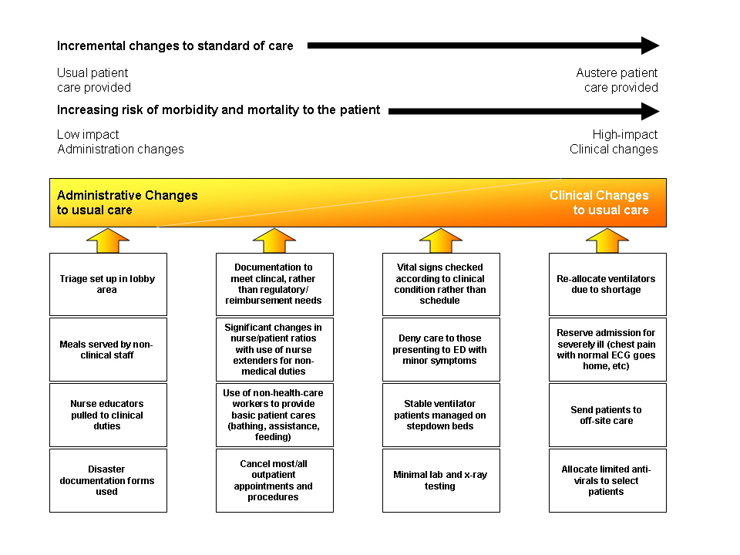
Process for implementing crisis standard of care (see flowchart addendum 4.3)
- Incident commander recognizes that systematic clinical changes will be required to allocate scarce resources to those most likely to benefit.
- Planning chief gathers any guidelines, epidemiologic information, resource information, and regional health care facility information and schedules meeting or conference call with IC and designees to clinical care committee.

- Clinical care committee is convened by IC – membership may vary depending on incident and facility resources:
  - Health care administrator
  - Medical Director (Medical Care Director)
  - Health care attorney (if possible)
  - Infection Control (for infectious incident)
  - Infectious disease (for infectious incident)
  - Critical care
  - Emergency medicine
  - Pediatrics
  - Nursing supervisor
  - Respiratory care supervisor
  - Chair of ethics committee
  - Community representative (if possible – similar to Institutional Review Board role)
  - Ambulatory care (clinics)
  - Other – may include lab, radiology, bioelectronics, pharmacy, palliative care, burn staff, etc.

- Clinical care committee reviews situation, outside guidance, and regional/state health care facility efforts and determines:
  - Methods to meet patient care needs (for example, use of non-invasive ventilation techniques, changes in medication administration techniques, use of oral medications and fluids instead of intravenous, etc.). These will generally be of limited value in correcting large demand/resource deficits, however. Use MDH scarce resource guidance (see Patient Care Strategies for Scarce Resource Situations).
  - Additional changes in staff responsibilities to allow specialized staff to re-distribute workload (for example, floor nurses provide basic ICU patient care while critical care nurses oversee these nurses and their patients) or would incorporate other health care providers, lay providers, or family members to provide assistance based on their skillset.
  - Mechanism for reassessment of local and regional health care facility efforts and strategies (e.g., assignment of liaison officer and establishment of regular communications loop with state Science Advisory Team and any regional entities).
  - Mechanism to summarize recommendations and changes and circulate to all staff and patients/families (concrete guidelines are important to provide clarity and reduce decision-making based upon emotional or subjective factors).

- Committee reviews options for:
• Location of care (triage of patients to critical care, floor care, off-site care, home based on disease severity)
• Assignment of resources (which patients will receive resources in limited supply – ventilators, anti-toxin, etc., or which will not be offered such interventions when there are competing demands).
- Committee summarizes recommendations for care for next operational period and determines meeting and review cycles for subsequent periods (eg: daily meeting, twice daily conference call, etc.) assuring that regional efforts at the MAC level or RHPC level are integrated into facility process/timelines.
1. Incident commander approves recommendations and integration into Incident Action Plan (IAP). Section chiefs and Command Staff briefed and PIO assures communications to all staff.
2. Information is disseminated to inpatient services, outpatient services, RHPC. Daily conference calls with RHPC involving critical care, infectious disease, command staff, as indicated by circumstances

Re-allocation of ventilators or other critical care or limited resources
- Current inpatients, patients presenting to the health care facility, and their family members are given verbal and printed information - by the triage nurse in the ED with reinforcement by physician - explaining the situation and explaining that resources may have to be restricted or re-allocated, even once assigned, in order to provide the care to those that will most benefit. A contact point (phone extension) for responding to patient/family questions and concerns should also be included, as should spiritual support contact information.

- Access controls should be implemented appropriate to the situation.

- Assure behavioral health resources and appoint palliative care unit leader if needed.

- Triage plan for each operational period:
a. Emergency department/Outpatient screening of patients (and denial of service to patients either too sick or too well to be benefited by evaluation/admission) based on current regional resources and regional/MDH guidance as well as facility resources.
b. Triage team – Two physicians from the affected discipline (usually two critical care or one critical care and one relevant specialty physician - infectious disease, burn surgeon, etc.) consider ventilator and other resource allocation decisions acting on data supplied by units/teams in concordance with MDH strategies (see appendix) and other evidence. (If ECMO is the resource in question one of the physicians should have ECMO expertise).
i. When two patients have essentially equal levels of illness/prognosis, a “first-come, first-served” policy should be used.
ii. When, according to guidelines or the triage team’s clinical experience, the prognosis is not equal, the patient with a substantially more favorable prognosis shall receive the resource.
iii. The triage team should ask for and receive whatever patient information is necessary to make a decision but should NOT consider subjective assessments of the quality of the patient’s life or value to society. (The treating physician should assure that the patient/family wishes to use the ventilator or other resources if they are available prior to asking the triage team for an opinion).
iv. Triage team should pass recommendations to the inpatient unit leader and document decision-making on templates in the affected patient(s) charts
v. Note that in some situations health care facility staff may participate on regional triage team on rotating basis.

- The inpatient unit leader should maintain situational awareness of the facility. This individual should have access to:
a. ED and other outpatients waiting for beds (both floor and critical care units)
b. Inpatient bed status including pending transfers into/out of critical care areas.
c. Clinical status of patients by unit (i.e., improving: able to move to floor status or discharge or worsening: may require critical care or may not be eligible for continued treatment). This requires ongoing contact between the inpatient unit leader and the clinical units to assure that information is up to date and accurate so that good decisions can be made. The leader will work closely with the Triage Team to determine the best use of beds available

- The process and rationale for resource assignment should be provided to the attending physician and family: Office of the Medical Director staff may act as messenger to the family as desired/necessary):
a. Grounds for the decision
b. An appeals process that allows a period of time (appropriate to the intervention being allocated – for ventilators 15 minutes) for the attending physician to request re-consideration of the decision if there is new objective information available that that patient’s prognosis is more favorable than determined by the triage team.
c. The resource allocation protocol and decisions should be reviewed by the clinical care committee and additional oversight physicians at set periods (e.g., every 24-48 hours) and as needed to assure the best evidence available is being used and that the decisions and the system are operating justly.
d. The inpatient areas supervisor and the attending physician will agree on the level of care required for the patient after the allocation decision is made – floor, intermediate, or ICU
e. Note: in most cases all means of available support should continue to be offered aside from the resource triaged, and should the patient improve or more resources become available they may re-qualify for a resource, unless decision expected to result in a non-survivable state (e.g., ventilator re-allocation).
f. Assure adequate symptom relief and comfort for all patients as possible based on the available resources

Addendum 4.2—Hospital scarce resource decision-making tree
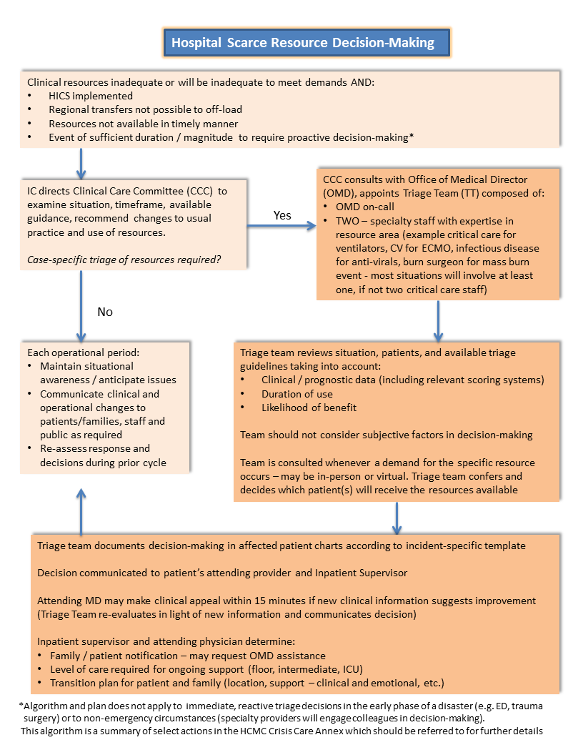

John L. Hick, Sharon Einav, MD, Dan Hanfling, MD, Niranjan Kissoon, MBBS, FRCPC, Jeffrey R. Dichter, MD, Asha V. Devereaux, MD, MPH, FCCP, Michael D. Christian, MD, FRCPC, FCCP on behalf of the Task Force for Mass Critical Care (2014, October) Surge Capabilities Principles, Volume 146 (Issue 4), Summplement, Pages e1S-e16S.
Sharon Einav, MD'Correspondence information about the author MD Sharon EinavEmail the author MD Sharon Einav, John L. Hick, MD, Dan Hanfling, MD, Brian L. Erstad, PharmD, Eric S. Toner, MD, Richard D. Branson, MSc, RRT, Robert K. Kanter, MD, Niranjan Kissoon, MBBS, FRCPC, Jeffrey R. Dichter, MD, Asha V. Devereaux, MD, MPH, FCCP, Michael D. Christian, MD, FRCPC, FCCP on behalf of the Task Force for Mass Critical Care (October 2014) Surge Capacity Logisitcs. CHEST Journal, Volume 146 (Issue 4) Pages e17S-e43s.
Minnesota state burn centers
Insert web link citation to the card set
The Glasgow Coma Scale (GCS) is a neurological scale commonly used in medical care. A score of 3 is the lowest possible score a patient can receive.
IOM/NAM Crisis Standards of Care (2009) table 4-14
Altered Standards of Care in a Mass Casualty Event (Current as of April 2005), Retrieved from Agency for Healthcare Research and Quality, Available at Appendix A, Expert Meeting on Mass Casualty Medical Care Participant List.

